## Complete list of A2 grammar contents

This is a list of all the grammar topics covered in level A2. But if you want to learn A2 grammar, we recommend studying the topics in the order that they appear in: Grammar points » [A2 Grammar lessons and exercises](https://test-english.com/grammar-points/a2/).

### Present tenses

A2 [Present simple vs present continuous](https://test-english.com/grammar-points/a2/present-simple-continuous/)  
A2 [Present perfect: Form and use](https://test-english.com/grammar-points/a2/present-perfect/)  
A2 [Present perfect or past simple?](https://test-english.com/grammar-points/a2/present-perfect-or-past-simple/)

### Past tenses

A2 [Past simple: Form and use](https://test-english.com/grammar-points/a2/past-simple-form-use/)  
A2 [Past continuous and past simple](https://test-english.com/grammar-points/a2/past-continuous-past-simple/)  
A2 [Past perfect](https://test-english.com/grammar-points/a2/past-perfect/)

### Future

A2 [Will vs be going to: Future](https://test-english.com/grammar-points/a2/will-vs-be-going-to/)  
A2 [Present continuous for future arrangements](https://test-english.com/grammar-points/a2/present-continuous-future-arrangements/)

### Verb tense reviews

A2 [Review of all verb tenses A2](https://test-english.com/grammar-points/a2/review-verb-tenses-a2/)

### Modals, the imperative, phrasal verbs, etc .

A2 [Have to, don’t have to, must, mustn’t](https://test-english.com/grammar-points/a2/have-to-dont-have-to-must-mustnt/)  
A2 [Should, shouldn’t](https://test-english.com/grammar-points/a2/should-shouldnt/)  
A2 [Might, might not: Possibility](https://test-english.com/grammar-points/a2/might-might-not/)  
A2 [May and might: What’s the difference?](https://test-english.com/grammar-points/a2/may-and-might-whats-the-difference/)  
A2 [Used to, didn’t use to: Past habits and states](https://test-english.com/grammar-points/a2/used-to/)  
A2 [How to use the verb ‘go’ in English](https://test-english.com/grammar-points/a2/use-verb-go-english/)  
A2 [The different uses of the verb ‘get’](https://test-english.com/grammar-points/a2/the-different-uses-of-the-verb-get/)  
A2 [‘Do’ vs ‘Make’: What’s the difference?](https://test-english.com/grammar-points/a2/do-vs-make-difference/)  
A2 [Verbs with two objects](https://test-english.com/grammar-points/a2/verbs-with-two-objects/)  
A2 [Stative vs dynamic verbs (or non-action vs action verbs)](https://test-english.com/grammar-points/a2/stative-vs-dynamic-verbs-or-non-action-vs-action-verbs/)  
A2 [Phrasal verbs: Transitive and intransitive, separable and inseparable](https://test-english.com/grammar-points/a2/phrasal-verbs-transitive-and-intransitive-separable-and-inseparable/)

### Conditionals, ****if****, ****wish****, etc.

A2 [First conditional and future time clauses](https://test-english.com/grammar-points/a2/first-conditional-future-time-clauses/)  
A2 [Second conditional](https://test-english.com/grammar-points/a2/second-conditional/)

### Passive

A2 [Present and past simple passive: be + past participle](https://test-english.com/grammar-points/a2/present-past-simple-passive/)

### Reported speech

A2 [Reported speech / Indirect speech](https://test-english.com/grammar-points/a2/reported-speech-indirect-speech/)

### -ing and the infinitive

A2 [Expressing purpose with ‘to’ and ‘for’](https://test-english.com/grammar-points/a2/purpose-to-for/)  
A2 [Infinitives and gerunds: Verb patterns](https://test-english.com/grammar-points/a2/infinitives-and-gerunds/)

### Articles, nouns, pronouns, and determiners.

A2 [Subject pronouns, object pronouns, possessive pronouns, possessive adjectives](https://test-english.com/grammar-points/a2/subject-pronouns-object-pronouns-possessive-pronouns-possessive-adjectives/)  
A2 [Something, anything, nothing, etc.](https://test-english.com/grammar-points/a2/something-anything-nothing-etc/)  
A2 [Much, many, little, few, some, any: Quantifiers](https://test-english.com/grammar-points/a2/much-many-little-few-some-any/)  
A2 [Too, too much, too many, enough](https://test-english.com/grammar-points/a2/too-too-much-too-many-enough/)  
A2 [Most, most of, the most](https://test-english.com/grammar-points/a2/most-most-of-the-most/)

### Relative clauses, relative pronouns and adverbs

A2 [Defining relative clauses: Who, which, that, where](https://test-english.com/grammar-points/a2/defining-relative-clauses-who-which-that-where/)

### Auxiliary verbs

A2 [So, neither: so am I, neither do I, etc.](https://test-english.com/grammar-points/a2/so-neither/)

### Adjectives and adverbs

A2 [Comparative and superlative adjectives and adverbs](https://test-english.com/grammar-points/a2/comparative-superlative-adjectives-adverbs/)  
A2 [No longer, any longer, anymore](https://test-english.com/grammar-points/a2/no-longer-any-longer-anymore/)

### Conjunctions and clauses

A2 [However, although, because, so, and time connectors](https://test-english.com/grammar-points/a2/however-although-time-connectors/)

### Prepositions

A2 [Prepositions of movement: Along, across, over, etc.](https://test-english.com/grammar-points/a2/prepositions-of-movement/)  
A2 [On time vs In time, At the end vs In the end.](https://test-english.com/grammar-points/a2/on-time-vs-in-time-at-the-end-vs-in-the-end/)

### Questions

A2 [Asking questions in English: Question forms](https://test-english.com/grammar-points/a2/asking-questions-in-english/)  
A2 [Subject questions, questions with preposition](https://test-english.com/grammar-points/a2/subject-questions-questions-preposition/)

### Present tenses

## Present simple: Form

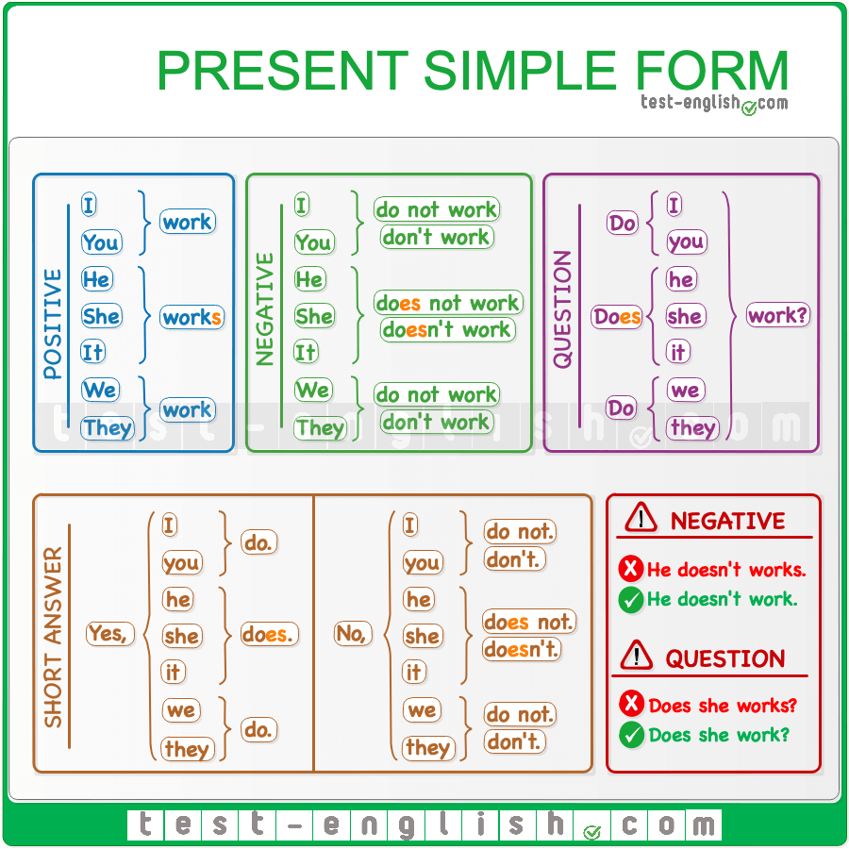

#### The spelling of ****he/she/it****

The spelling of **he/she/it** is different in the present simple. Check how it changes below. The spelling is the same for all the other persons.

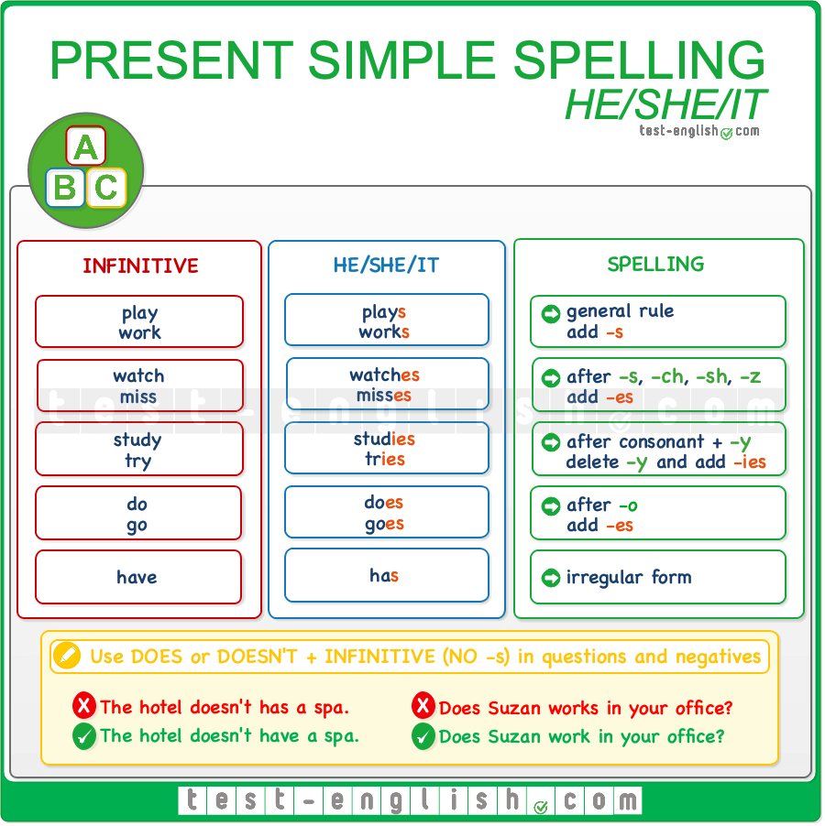

## Present simple: Use

#### Habits or situations that happen regularly

We use the present simple for actions that we do (or we don’t do) regularly:

* I **wash** my hair every day.
* I never **go** to the library.
* I sometimes **go** to the library.

#### Permanent situations or things that are usually or often true

* I **don’t drink** coffee.
* She**’s** very tall.
* I **have** two brothers.
* Water **boils** at 100 degrees.
* I **like** soup.

#### Adverbs of frequency

We often use the present simple with [**adverbs of frequency**](https://test-english.com/grammar-points/a1/adverbs-frequency/) (always, sometimes, etc.) and **expressions of frequency** (once every three months, twice a week, every other day, etc.).  
  
**Adverbs of frequency** go in mid position (before the main verb or after **be**).

* She doesn’t **often** eat hamburgers.
* He **usually** gets up very early.
* I am **never** late.

**Expressions of frequency** go at the end of the sentence

* We go to the cinema **once a month**.
* I buy clothes **twice a year**.

## Present continuous: Form and spelling

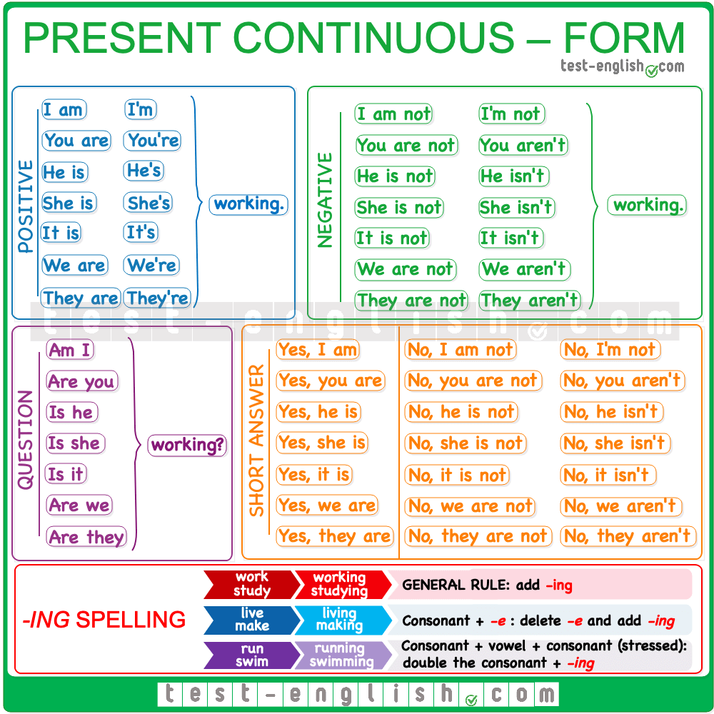

## Present continuous: Use

#### Actions in progress

We use the present continuous to talk about things that are happening now or ‘around now’ (a time around this moment, such as these days, weeks or months)

* I can’t talk now. I’**m brushing** my teeth.
* I finished the Lord of the Rings and now I**’m reading** a new book.

#### Temporary actions

The present continuous is used for temporary actions:

* I’**m going** to work by bus this week because my car is at the garage.
* I’**m living** with my cousins temporarily.

#### With expressions meaning ‘now’ or ‘around now’.

The present continuous often appears next to expressions such as **now**, **these days, this week/month,** or **at the moment**.

* He**’s studying**a lot this week.
* I’**m not feeling** very well these days.

## Stative verbs

[**Non–action** **verbs**](https://test-english.com/grammar-points/a2/stative-vs-dynamic-verbs-or-non-action-vs-action-verbs/) (or **stative verbs**) cannot be used in the present continuous. They must be used in the present simple. The most frequent are the verbs of the **senses** (**hear, see, smell, etc.** ), verbs of **opinion** (**believe, consider, like, love, hate, prefer, think, etc.**), and other verbs like **be, have, need, want, etc**.

* Please, give me my money; I **need** it now.
* Look at her; she **seems** sad.

#### Present simple vs present continuous

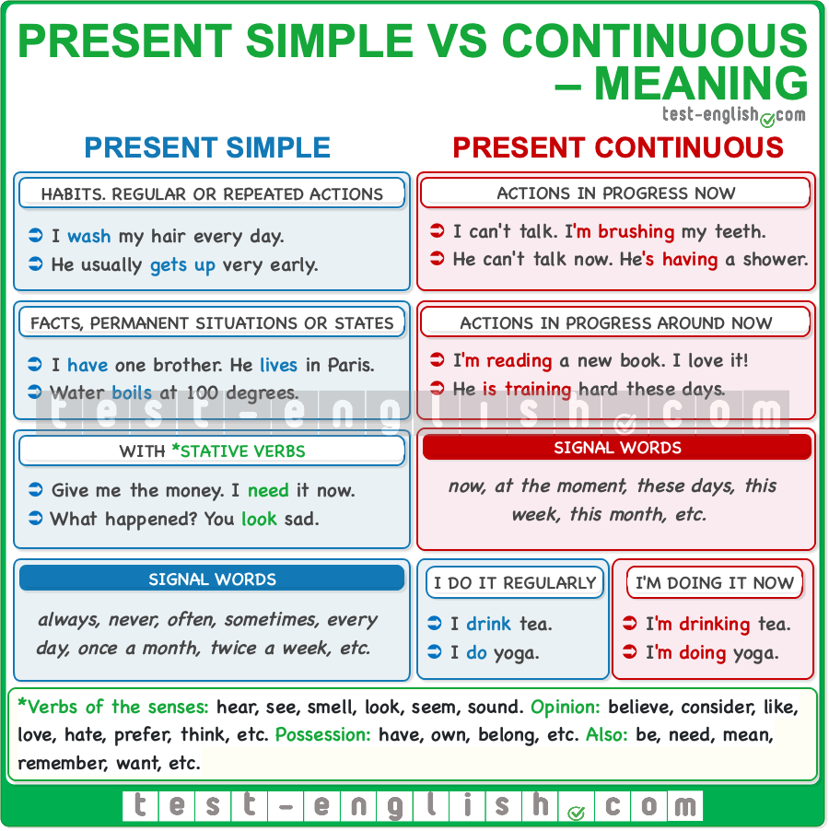

## Present perfect: Form

We form the present perfect tense with the verb **have** and the past participle of the verb. The past participle is the same as the past simple (**-ed**) for regular verbs. For irregular verbs, it’s the form in the 3rd column.  
  
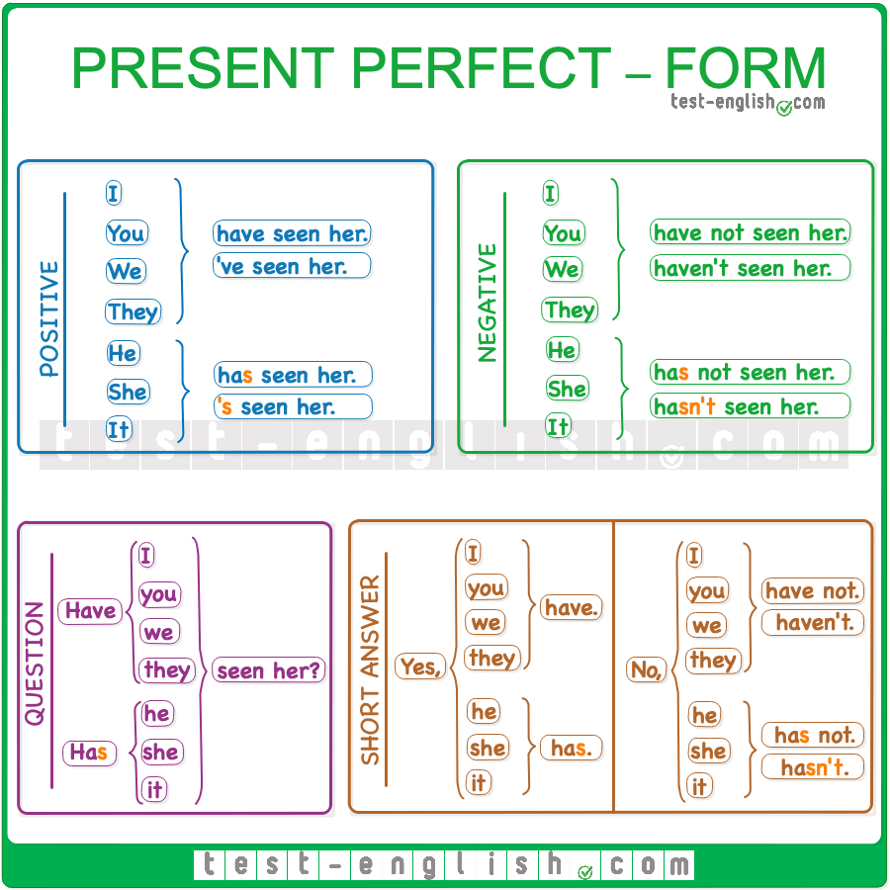

## Present perfect: Use

We normally use the present perfect to talk about past events that have a connection with the present, for example, news or past experiences. We can also use the present perfect to talk about situations that started in the past but which are still true in the present. Check the grammar chart below:  
  
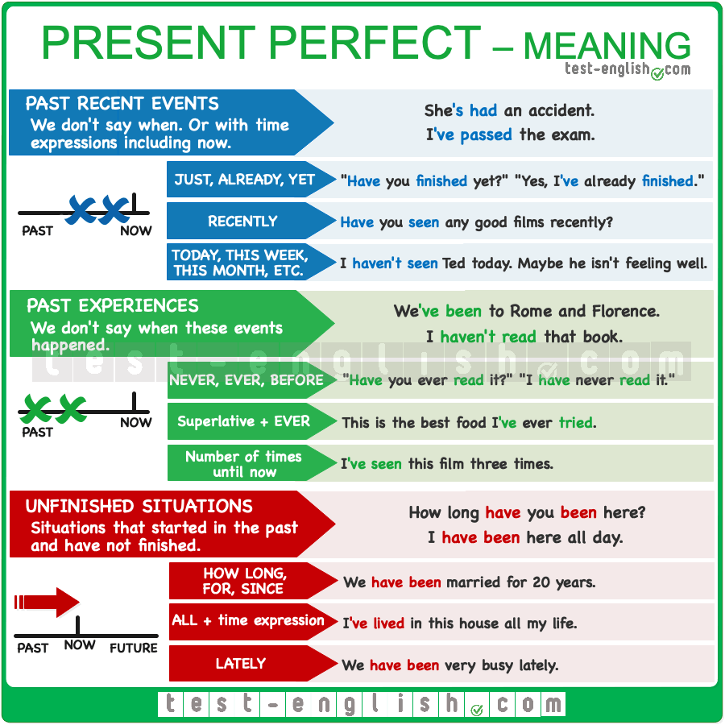

### Recent events and news

We use the present perfect to talk about recent events or news. We don’t say when these events happened.

* I’**ve passed** the test!
* She’**s broken** her arm.
* The president **has travelled** to Cuba.

#### ⇒ Just, yet, already

We often use the present perfect with the words **just, yet, already**.  
  
We use **just** in (+) sentences to say that something happened very recently (like minutes ago).

* I’**ve just seen** Peter in the street.
* He looks happy because he’**s just got married**.

We use **yet** in (-) and (?) sentences. We put it at the end of the sentence.

* **Have** you **washed** the dishes **yet**?
* I **haven’t** **called** him **yet**.
* She **hasn’t arrived yet**.

We use **already** in(+) sentences to say that something happened before now (usually earlier than we expected).

* I **have already finished**.
* We **have already arrived**.

### Life experiences

We often use the present perfect to talk about past experiences in our lives. We don’t say when these experiences happened.

* I’**ve run** the Boston Marathon twice.
* She’**s** never **been** on a cruise.
* I’**ve been** here before.

#### ⇒ Never, ever, before

When we ask about someone’s life experiences, we often use the word **ever**.

* **Have** you **ever** **read** this book?
* **Have** you **ever** **been** to India?

When we talk about life experiences, we often use the words **never** or **before**.

* She **has never been** late.
* I think I **have seen** this film **before**.

### Unfinished actions

#### ⇒ How long, for, since

We use the present perfect with the words **how long**, **for**, **since** to talk about actions or situations that started in the past and still continue or are still true now.

* I’**ve lived** in Oslo **since** I was born. (=I was born in Oslo and I still live in Oslo)
* They **have been** married **for** 25 years. (=They got married 25 years ago and they are still married)

We use **how long** in questions to ask about the duration of an action or situation.

* **How long** **has** she **been** a teacher?
* **How long** **has** she **had** her car?

We use **for** + a period of time, e.g. **for** two weeks, **for** ten years, **for** ten days, **for** a few hours, etc.

* We’**ve been** here **for** a few hours.
* They’**ve been** married **for** 10 years.

We use **since** + a moment in the past (the beginning of a period of time), e.g. **since** I was born, **since** 10 o’clock, **since** last Wednesday, etc.

* We’**ve been** here **since** 4 o’clock.
* They’**ve been** married **since** 2010.

## Be careful with these common mistakes!

We use the present perfect, and not the present simple for actions or situations that started in the past and are still true now.

* We**are** friends since first grade. 
* We’**ve been** friends since first grade. 

We use **for…**and NOT **since…ago** to introduce a period of time.

* They’ve been married **since 10 years ago**. 
* They’ve been married **for 10 years**. 

## Present perfect or past simple?

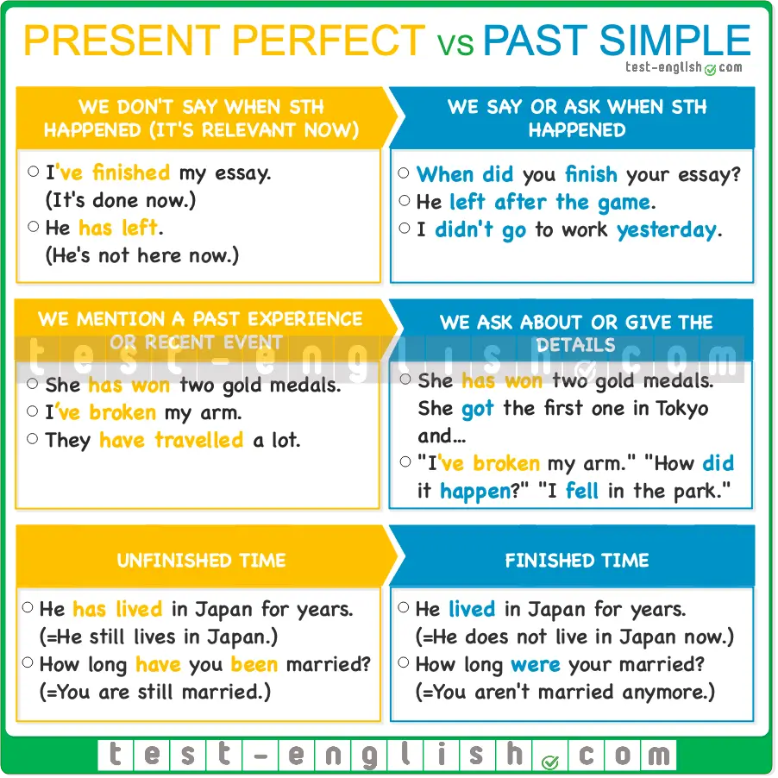

## Past events or experiences

#### Present perfect: it’s not important when something happened

We use the present perfect to talk about recent events or about people’s experiences when the time when these events happened is not important and we don’t mention it.

* I’**ve been** to Malaysia. (**When** is not important. The important thing is that I have this experience now.)
* She’**s won** three gold medals.
* I’**ve broken** my arm.

#### Past simple: We say or ask when something happened

We use past simple to talk about completed actions in the past. We often say or ask when these actions happened.

* We **have been** to Malaysia **last year**. 
* We **went** to Malaysia **last year**.  
* *She* ***won*** *three gold medals* ***at the last Olympic Games****.*
* **When** **did** you **break** your arm?

#### In conversation

We often start a conversation about recent events or people’s experiences using the present perfect, but if we continue talking or asking about the details of that event, we use the past simple.

* John: I’**ve been** to the cinema.
* Patrick: What **did** you **see**?
* John: I **saw** a very good film by…
* Sarah: Oh, you’**ve broken** your arm!
* Rachel: Yes, I **have**.
* Sarah: How **did** it **happen**?
* Rachel: It **happened** yesterday while I was riding my bike.
* I do judo, and I’**ve won** some competitions. In fact, I’**ve won** two medals. I **got** the first one in Singapore in 2002. The second one **was** different. It **was** in Tokyo, and I **was** older.

## Duration with ****how long****, ****for**** and ****since****

We use the present perfect with **how long**, **for**, **since** to talk about actions or situations that started in the past and still continue or are still true **now**.

We use the past simple with **how long**, **for**, **since**to talk about actions or situations that started and finished in the past. Compare:

* He**‘s lived** in New York for ten years. (=He lives in New York now)
* He**lived** in New York for ten years. (=He does NOT live in New York now)
* How long **have** you **worked** in the bank? (=You work in the bank now)
* How long **did** you **work** in the bank? (=You do NOT work in the bank now)

### Past tenses

## Past simple: Form

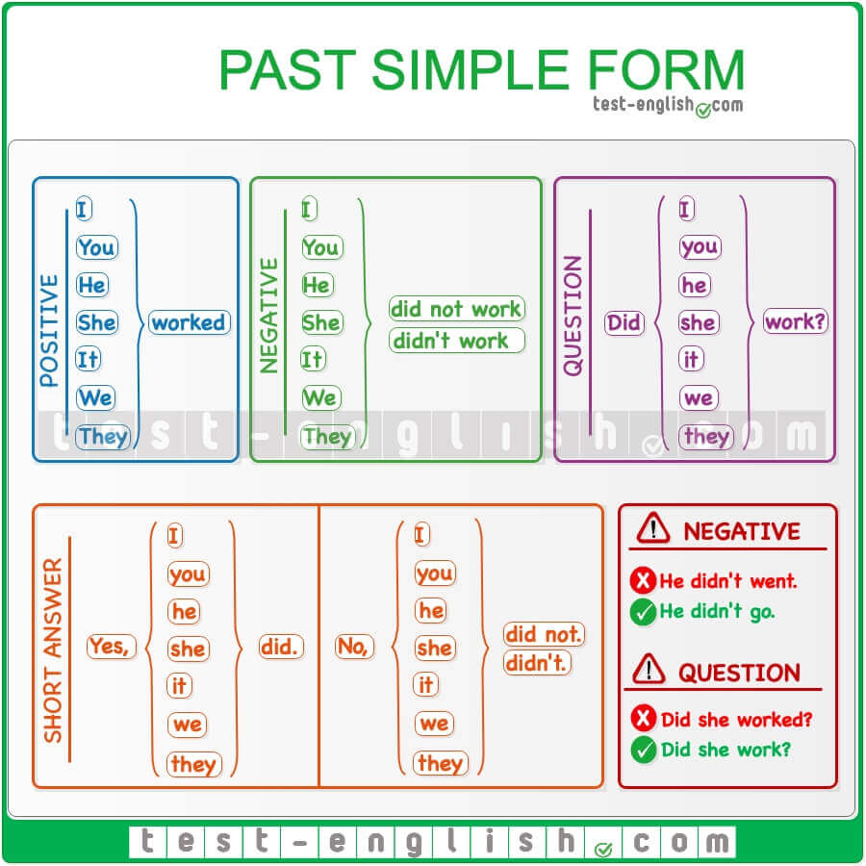

#### Spelling of regular verbs

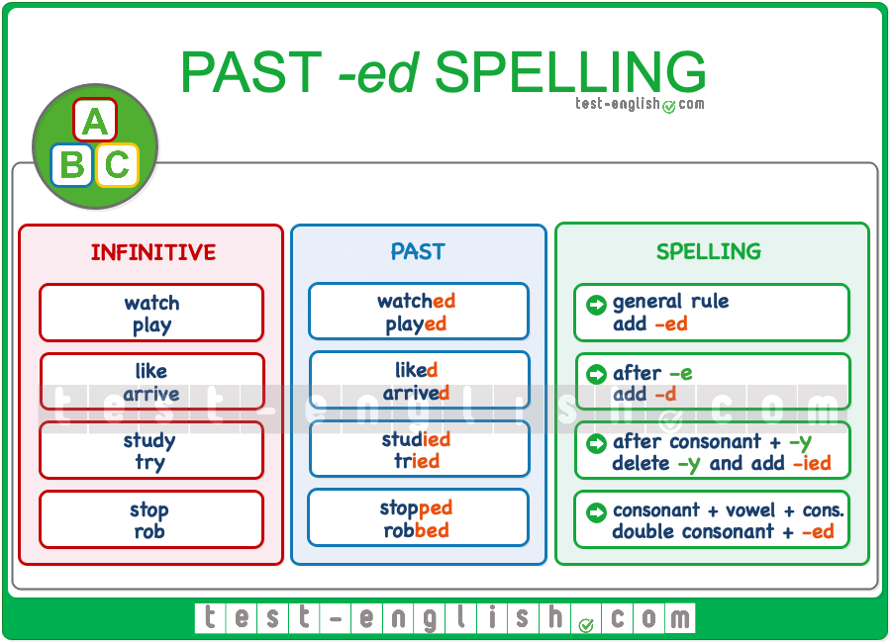

## Past simple: Use

#### Completed actions in the past

We use the past simple to talk about actions or events that happened in the past. We know, or we say, when the events happened.

* I **saw** Jim yesterday.
* We **didn’t go out** last Saturday. We **stayed** at home.
* She **moved** to Chester three years ago.

#### Past habits

We use the past simple to talk about past habits (things that we did more or less often).

* She **washed** her hair every day.
* She **worked** as a nurse.
* I often **played** in the park when we were children.

#### Situations that were true in the past

We also use the past simple to talk about things that were true in the past.

* My grandfather **had** two brothers.
* He **lived** with my grandparents as a child.

#### Events in chronological order

We use the past simple to describe the main events of a story in chronological order.

* When I **arrived** home, I **took off** my shoes and then I **relaxed** on the sofa.

## The past continuous: Form

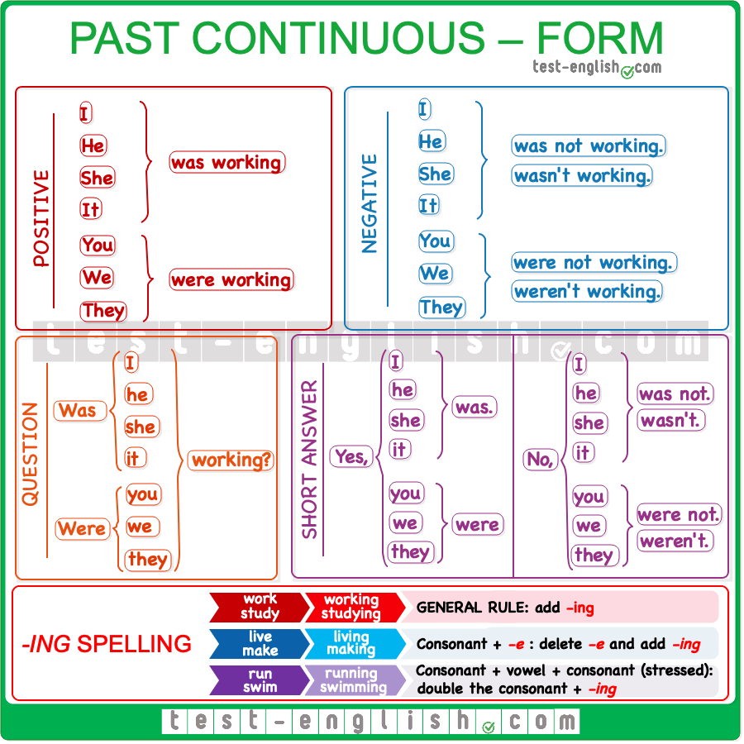

## The past continuous: Use

#### Actions in progress

We use the past continuous to talk about **actions** that were **in progress** (not finished) at a specific moment **in the past**.

* ‘What **were** you **doing** at 9?’ ‘I **was studying**.’
* When I saw them yesterday, they **were arguing**.

The specific moment in the past can be described by a **time expression** (at 9 a.m., at midday, at lunchtime, all morning, all day, etc.):

* They were swimming **at 7 in the morning**.
* **At midday**, they were still working.

Or by a **simple past sentence**:

* They were swimming **when I saw them**.
* **When she arrived**, they were still working.

#### Describing a scene

We often use the past continuous at the beginning of a story to describe the situation.

* It **was getting** dark, and I **was walking** fast. Suddenly …

## Past simple vs Past continuous

We use the [past simple](https://test-english.com/grammar-points/a2/past-simple-form-use/) for **completed actions in the past**, and we use the past continuous for **actions in progress** (not finished) in the past.

* We **ate out** yesterday. (the action is finished)
* We **were eating** at 9. (the action was not finished)

The past continuous describes a longer action or situation, and the past simple describes a shorter action or event.

* When I **met** Susan, she **was having** a drink at a terrace with a friend.
* We **didn’t go out** because it **was raining**.

The short action in past simple often interrupts the longer action in past continuous.

* He **was playing** football when he **broke** his arm.
* When I **went** to bed, it **was raining**.

We use the past simple for completed actions that happened one after the other. Compare:

* When he **arrived**, she **was having** a shower. (The action of having a shower started **before** he arrived)
* When he **arrived**, she **had** a shower. (The action of having a shower started **after** he arrived)

## Past perfect form and use: Grammar chart

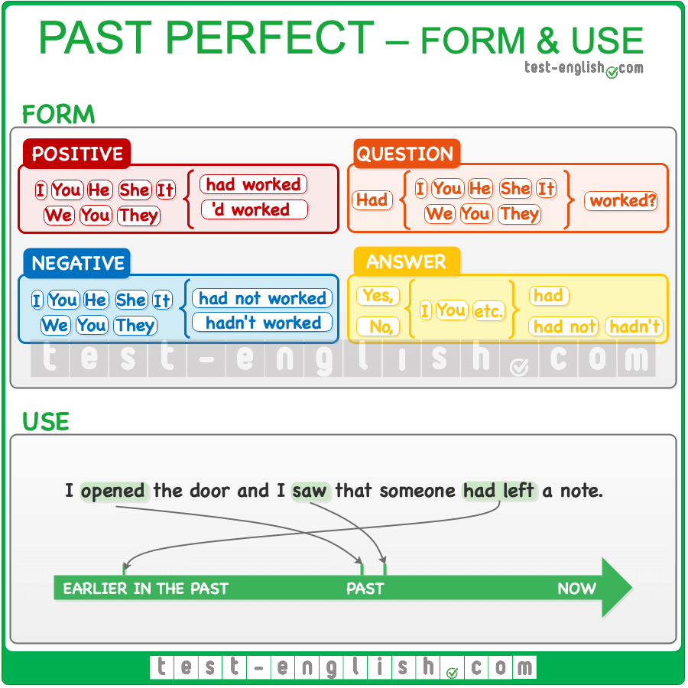

## Past perfect form

We make the past perfect with **had**/**hadn’t + past participle**: **-ed** for regular verbs and the **3rd column** form for irregular verbs.

* I **hadn’t been** there before.
* She **had never** worked.

The past perfect is the same for **all the persons**.

* I/you/he/she/it/we/they **had left** when I arrived.

We can contract **had** to **‘d**.

* I called him, but he’**d gone** to a meeting.

## Past perfect use

We use the past perfect when we are talking about the past and then we want to talk about something that happened earlier in the past.

* When I left work, I saw that somebody **had stolen** my car.
* Yesterday my mother told me that she **had seen** you in the park.

## Past perfect or past simple?

We use the past simple to describe a series of past events in chronological order, and we use the past perfect to make clear that one of the events happened before. Compare these two sentences:

* When I arrived, she **left**. (=She left **after** I arrived.)
* When I arrived, she **had left**. (She left **before** I arrived.)

## Be careful with this common mistake!

The contraction **‘d** can be **had** or **would**. Remember that we use an infinitive form after **would** and a past participle after **had**.

* I**‘d** **love** to go to your party. (= **would**)
* I noticed that he**‘d** **eaten** my cake. (= **had**)

### Future

## Will vs Be going to: Grammar chart

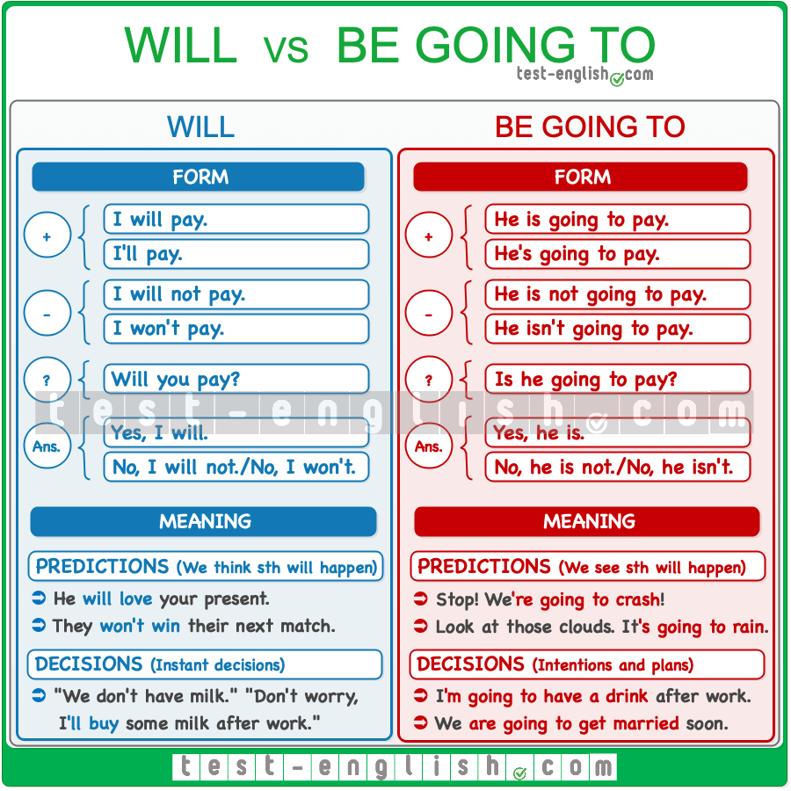

## Predictions

Use **will** to talk about something that you think will happen.

* I think he’**ll win** the election.
* He **will be** a good doctor.

Use **be going to** to talk about something that you see is going to happen (there is present evidence).

* Don’t drive like a crazy man. We’**re going to have** an accident!
* The doctor said I’**m going to have** a girl.

Sometimes, there’s little difference between **will** and **be going to** for predictions. Compare:

* The conference starts in 10 minutes. We **are going to be** late. (=I can **see** that we cannot be at the conference in 10 minutes)
* We need to hurry up. We’ll be late for the conference. (=I **think** we will be late)

## Decisions

Use **will** for decisions that you take at the moment of speaking (instant decisions).

* ‘Oh, we don’t have sugar.’ ‘Don’t worry, I’**ll buy** some.’

Use **be going to** for decisions that you have already taken at the moment of speaking (intentions or plans).

* ‘Why are you undressing?’ ‘Because I’**m going to go** for a swim.’

Compare these two sentences:

* ‘Sarah said she needs to talk to you.’ ‘Oh, I didn’t know. I’**ll call her** in a minute.’ (=I took the decision **while** having this conversation.)
* ‘Sarah said she needs to talk to you.’ ‘Yes, I know. I’**m going to call her** in a minute.‘ (=I took the decision **before** having this conversation.)

## Present continuous for future arrangements

We often use the present continuous to talk about the future, especially about future plans when we have **decided on a time and a place** with other people. We normally use a future time expression, e.g. **tomorrow**, **next week, at 7,** **etc**.

* I’**m meeting** Sally at 7. (=I have talked to her, and we have arranged to meet.)
* I’**m flying** to New York tomorrow morning. (=I have the ticket.)
* We’**re getting married** next July. (=We have decided it, and we have probably already made reservations for the restaurant, etc.)

The present continuous for future arrangements is very common with verbs of travelling and when we are meeting people.

* I’**m leaving** very early tomorrow. I’**m taking** the 7.30 train.
* I’**m playing** golf with Jack next Saturday. Would you like to come?
* I’**m seeing** the dentist after class.

## Present continuous vs ****Be going to****

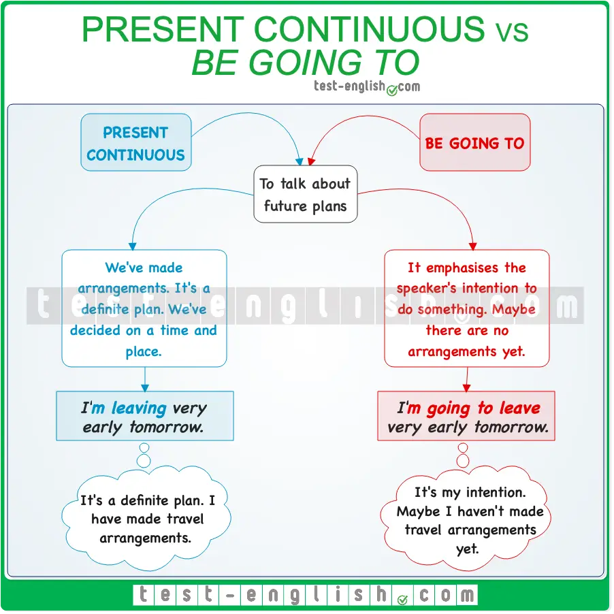

We can normally use the present continuous or **be going to** to talk about future plans.

* I’**m leaving** very early tomorrow.
* I’**m going to leave** very early tomorrow.

But we prefer using the present continuous when we have made **arrangements** (i.e. decided on a place and time with somebody else). When use **be going to**, we put the emphasis on our **intention** to do something.

* I’**m going to study** for the exams tomorrow. (=It’s my intention)
* I’**m leaving** at 8 tomorrow. (=It’s an arrangement)
* ‘Your car is dirty.’ ‘I know. I’**m going to wash** it tomorrow.’ (=It’s my intention, but I haven’t arranged to do it)

## ****Will**** for decisions

Use **will** for decisions that you take at the moment of speaking (instant decisions).

* ‘Oh, we don’t have sugar.’ ‘Don’t worry, I’**ll buy** some.’

## ****Be going to**** or ****will**** for predictions

We use **be going to** or **will** (NOT the present continuous) to make predictions about the future. (⇒ See Grammar points » A2 Grammar » [Will vs be going to – Future](https://test-english.com/grammar-points/a2/will-vs-be-going-to/))

* I think he’**ll win** the election.
* The doctor said I’**m going to have** a girl.

### Verb tense reviews

## Present tense review

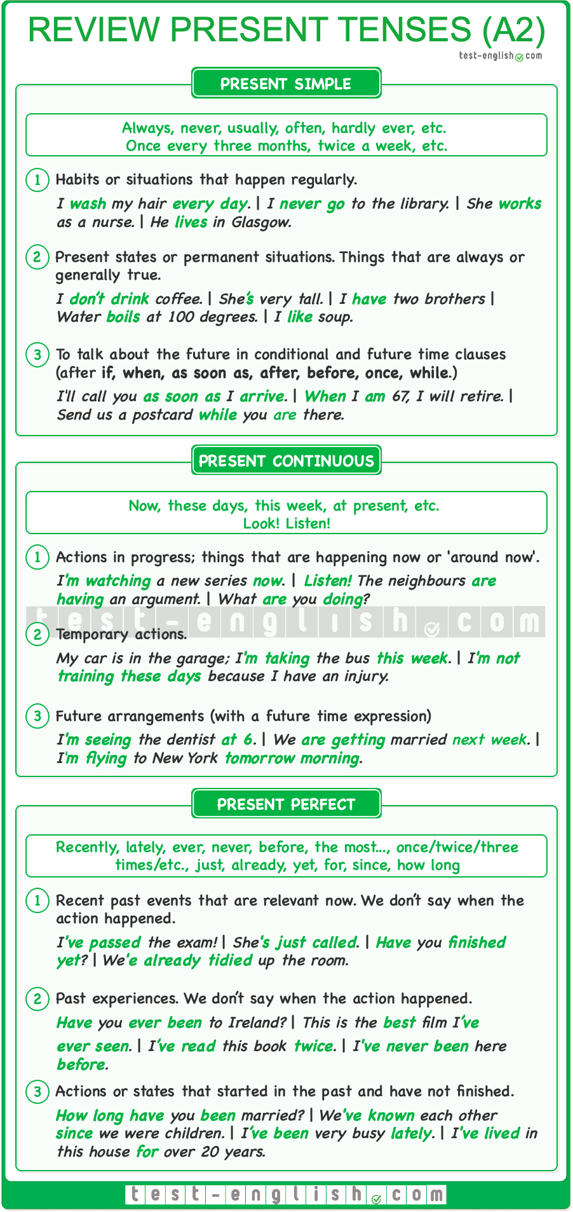

#### Present simple

1 Habits or situations that happen regularly.

* I **wash** my hair every day.
* I never **go** to the library.
* She**‘s** always late.

2 Permanent situations, or things that are always or usually true.

* I **don’t drink** coffee.
* She**‘s** very tall.
* I **have** two brothers.

#### Present continuous

1 Actions in progress, happening now or ‘around now’.

* I can’t talk now. I**‘m brushing** my teeth.
* I finished your book, and I**‘m reading** a new one now.

2 Temporary actions.

* My car’s in the garage. I**‘m taking** the bus this week.
* I**‘m not training** because I have an injury.

3 Future arrangements.

* I**‘m meeting** Sally at 7.
* We **are leaving** early tomorrow.

#### Present perfect

1 Recent events –we don’t say when. (Common with **already, yet, just, recently, today, this week, etc.**)

* She**‘s had** an accident.
* **Have** you **finished** yet?
* He**‘s changed** jobs recently.
* **Have** you **seen** Peter today?

2 Past experiences –we don’t say when. (Common with **never, ever, before,** superlative + **ever**, number of times until now.)

* We**‘ve been** to Italy.
* **Have** you ever **eaten** insects?
* This is the best food I**‘ve** ever **eaten**.
* I**‘ve read** this book three times.

3 Unfinished situations from the past until now. (Common with **how long, for, since, all** + time, **lately**.)

* How long **have** you **been** here?
* We **have been** married for 20 years.
* I**‘ve liked** chocolate all my life.
* I**‘ve been** very busy lately.

## Past and future tense review

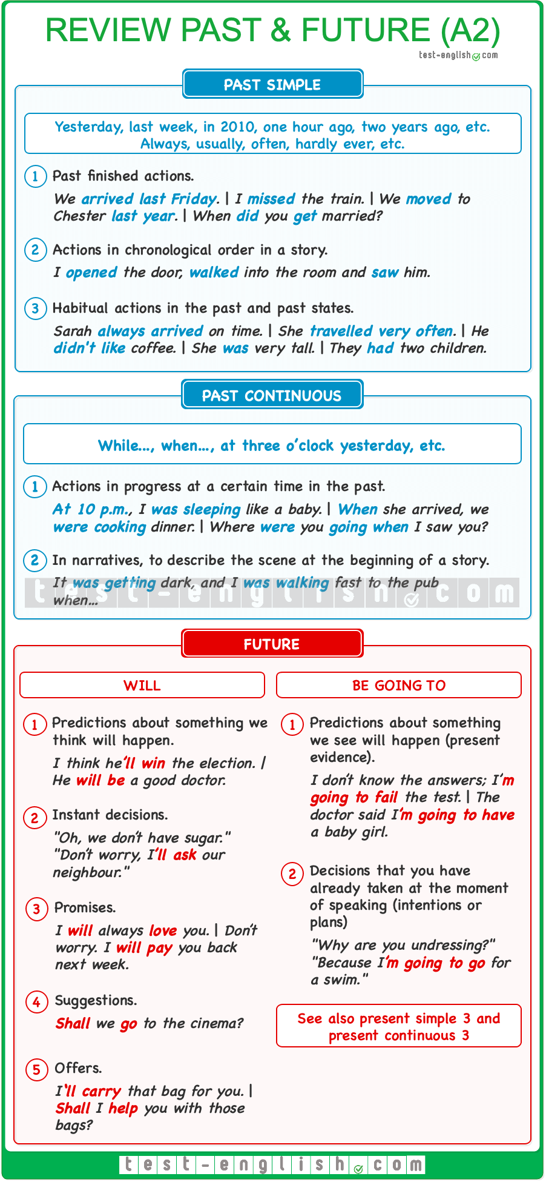

### Past tenses

#### Past simple

1 Actions completed in the past.

* I **saw** Jimmy yesterday.
* She **moved** to Chester two years ago.

2 Actions in chronological order in a story.

* When I **arrived** home, I **took off** my shoes and **turned on** the TV.

3 Past habits or situations that were true in the past.

* We often **played** in the park after school.
* He **lived** with his grandparents when he was a child.

#### Past continuous

1 Actions in progress at a certain time in the past.

* What **were** you **doing** yesterday at 7?
* When he arrived, I **was sleeping**.
* They **were arguing** when I last saw them.

2 At the beginning of a story, to describe the scene.

* It **was getting** dark, and I **was walking** to the pub when suddenly…

### Future forms

#### ****Will**** + infinitive

1 Decisions that we take at the moment of speaking.

* “We don’t have sugar.” “Don’t worry, I**‘ll buy** some.”
* I**‘ll have** a burger and chips, please.

2 Predictions about what we think will happen.

* I think he**‘ll win** the election.
* You **will be** a good doctor.

3 Promises.

* I **will** always **love** you.
* Don’t worry. I **will pay** you back next week.

4 Suggestions (**Shall we**…?).

* **Shall we go** to the cinema this weekend?

5 Offers (**I will** or **Shall I/Shall we**…?).

* I**‘ll carry** that bag for you.
* **Shall I help** you with those bags?

#### ****Be going to**** + infinitive

1 Intentions or plans.

* Please, pass me the remote. I**‘m going to watch** TV.
* This summer I**‘m going to look** for a job.

2 Predictions about what we see is going to happen (present evidence).

* Slow down! We**‘re going to have** an accident.
* The doctor said I**‘m going to have** a girl.

#### Present continuous

See present simple use 3 and present continuous use 3 above.

### Modals, the imperative, phrasal verbs, etc .

## ****Must/mustn’t, have to/don’t have to****: Form

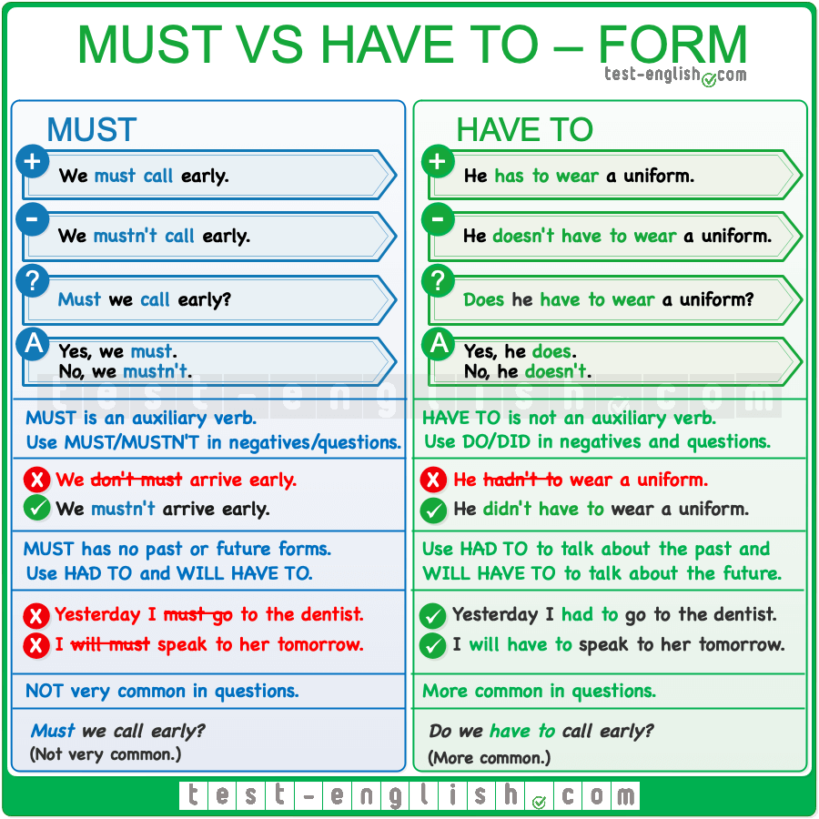

### ****Must/mustn’t****

#### Use ****must**** + infinitive without ****to****

**Must** is a modal verb, and modal verbs are followed by an infinitive without **to**.

* I **must to go** to the doctor. 
* I **must go** to the doctor. 

#### No ****-s****

Modal verbs don’t add **-s** after **he/she/it**.

* He **must comes** with us. 
* He **must come** with us. 

#### Use ****must/mustn’t**** in negatives and questions

**Must** is an auxiliary verb. This means that it has a negative and an interrogative form. Do not use **do/did** in negatives and questions.

* We **don’t must arrive** early. 
* We **mustn’t arrive** early. 
* **Do** we **must arrive** early? 
* **Must** we **arrive** early? 

### ****Have to/don’t have to****

#### Use ****do**** and ****did in**** negatives and questions

The verb **have** in **have to** is not an auxiliary verb. Use **do/don’t, does/doesn’t, did/didn’t** in questions and negative sentences in present and past.

* **Have** you**to** get up early tomorrow? 
* **Do** you **have to** get up early tomorrow? 
* **Did** you **have to** buy a new sound card?
* We **don’t have to** stay until the end.

#### No contraction

The verb **have** in **have to**cannot be contracted to **‘ve**.

* I**‘ve to study** for the exam tomorrow. 
* I **have to study** for the exam tomorrow. 

#### Past and future forms

Only **have to** has a past and a future form. **Must** does not have a past or a future form.

* Yesterday, I **must** take a taxi. 
* Yesterday, I **had to** take a taxi. 
* You **will must** take a taxi if it rains tomorrow. 
* You **will have to** take a taxi if it rains tomorrow. 

## Must vs have to, Mustn’t vs Don’t have to: Use

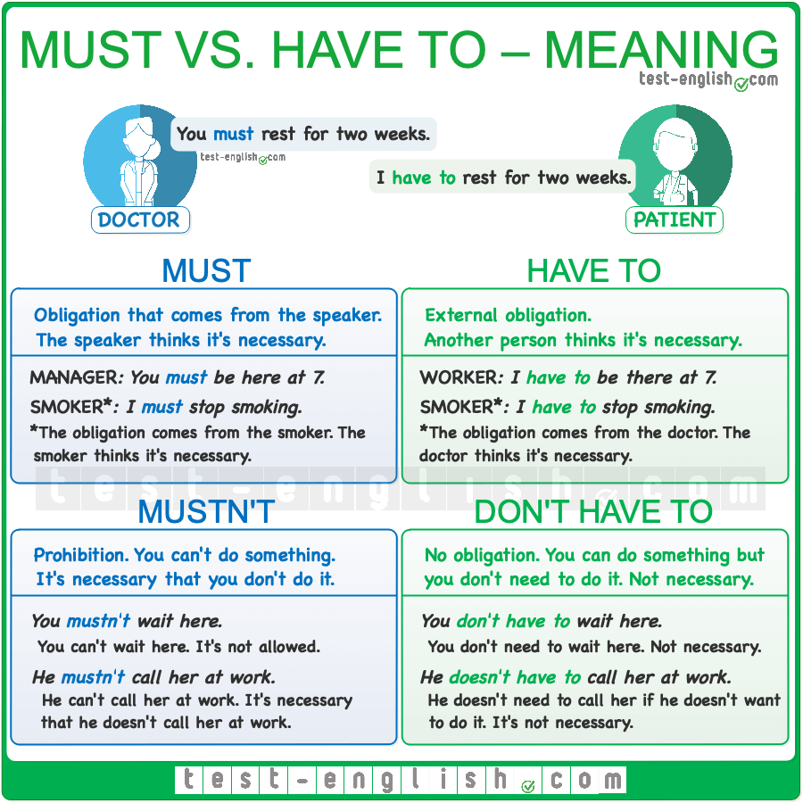

### ****Have to****

#### Rules and obligations

We use **have to** to talk about **rules and obligations**, something that is **necessary**.

* I **have to get** to work before 7 tomorrow.
* The car broke down and we **had to call** a taxi.

### ****Must****

#### Rules and obligations

**Must** is very similar to **have to**. We use **must** + infinitive (without **to**) to talk about **rules and obligations**.

* I **must go** to the doctor.
* I **must get up** early tomorrow.

### ****Don’t have to****

#### Don’t need to – not necessary

If you **don’t have to** do something, it means that you ‘don’t need to’ do something (there is no obligation). You can do it but you don’t need to do it if you don’t want to do it.

* You **don’t have** to pick me up at the station. I can take a taxi. (=You can pick me up, but you don’t need to do it).

### ****Mustn’t****

#### Prohibition

Use **mustn’t** to talk about something that you can’t do. It’s necessary that you don’t do it.

* You **mustn’t call** me before 8. (=You can’t call me before 8.)
* I **mustn’t lose** my concentration now.

## ****Must**** vs ****have to****

### ****Must****

#### Obligation from the speaker

We normally use **must** to talk about obligations that come from the opinion of **the speaker**. The speaker thinks it’s necessary or important to do something.

* MANAGER: You **must get up** early tomorrow. The meeting is at nine. (=The obligation comes from the manager. The manager thinks it’s necessary.)
* DOCTOR: You **must stop** smoking. (=It’s the doctor’s opinion. The doctor thinks it’s necessary.)
* SMOKER: I **must stop** smoking. (=It’s the smoker’s opinion. The smoker thinks it’s necessary to stop smoking.)

### ****Have to****

#### External obligation

We normally use **have to** when there’s an **external obligation**. The obligation doesn’t come from the speaker’s opinion; another person thinks it’s necessary.

* WORKER: We **have to get up** early tomorrow. The meeting is at nine. (=The obligation comes from the manager, not from the worker.)
* SMOKER: I **have to stop** smoking. (=It’s the doctor’s opinion, not the smoker’s opinion. The doctor thinks it’s necessary.)

## ****Mustn’t**** vs ****don’t have to****

### ****Don’t have to****

#### You don’t need to do it; not necessary; no obligation

**Don’t have to** and **mustn’t** have **opposite** meanings. We say that we **don’t have to** do something when we **don’t need to** do something; we can do it, but it’s **not necessary**.

* You **don’t have to wait** here. (=You can do it, but it’s not necessary)

### ****Mustn’t****

#### Prohibition; it’s necessary that you don’t do it

We say that we **mustn’t** do something when we cannot do something; it is **necessary** that we don’t do something.

* You **mustn’t wait** here. (=You cannot do it; it’s against the rules)

## ****Should, shouldn’t****: Form

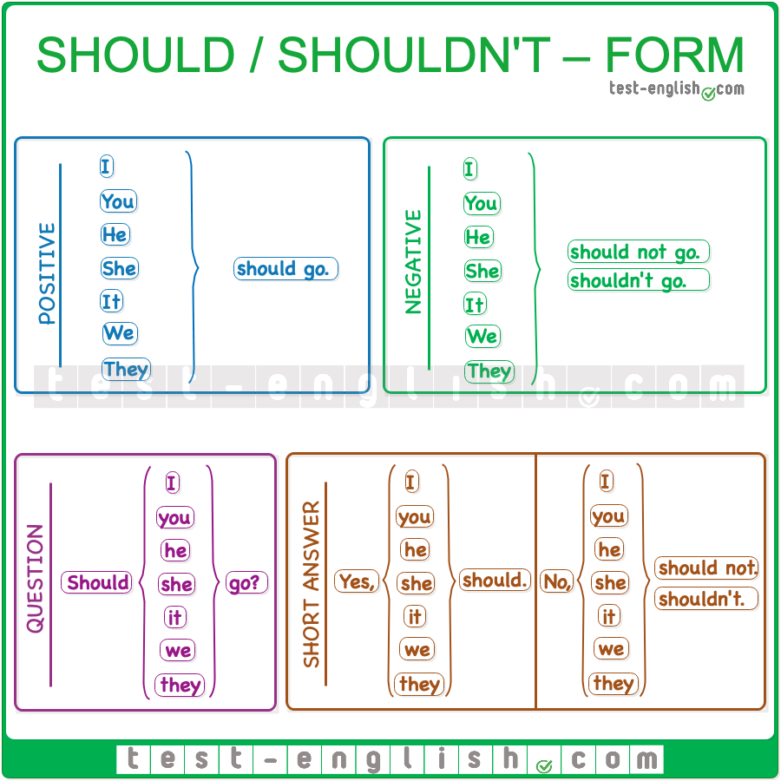

#### The same form for all persons

The form of **should** is the same for all persons:

* I/you/he/she/it/we/you/they **should** see a specialist.

#### ****Should(n’t)**** + infinitive

**Should** is a modal verb, and all modal verbs are followed by an **infinitive** (without **to**).

* You **should to listen** to me. 
* You **should listen** to me. 

#### ****Should not= shouldn’t****

The negative form of **should** is **should not** or **shouldn’t**.

* You **should not be** here. = You **shouldn’t be** here.

#### Questions

To ask questions, we use **should** + subject + infinitive. We don’t use the verb **do** to ask questions.

* **Do** we **should** call him? 
* **Should we call** him? 

## ****Should, shouldn’t****: Use

#### Giving advice

We use **should** or **shouldn’t**to give somebody advice and to say what is or isn’t the right thing to do.

* You look tired. You **should have** some rest.
* He **shouldn’t drive** so fast. He’ll have an accident one day.

#### ****I think you should …****

We often say **I think … should** **…** to give somebody advice.

* **I think you should buy** a new pair of shoes for the party.
* **I think we should go** home; it’s very late.

🔍 **Note** that in a negative sentence, we often say **I don’t think… should…** (NOT **I think… shouldn’t…**)

* **I think you shouldn’t call** her now; she’s very upset. 
* **I don’t think you should call** her now; she’s very upset. 

We often say **Do you think … should …**to ask for advice.

* **Do you think I should look** for another apartment?

#### ****Ought to, ought not to****

We can also use **ought to** instead of **should** and **ought not to** instead of **shouldn’t**.

* You **ought to have** some rest.
* He **ought not to drive** so fast.

## When do we use ****might**** and ****might not****?

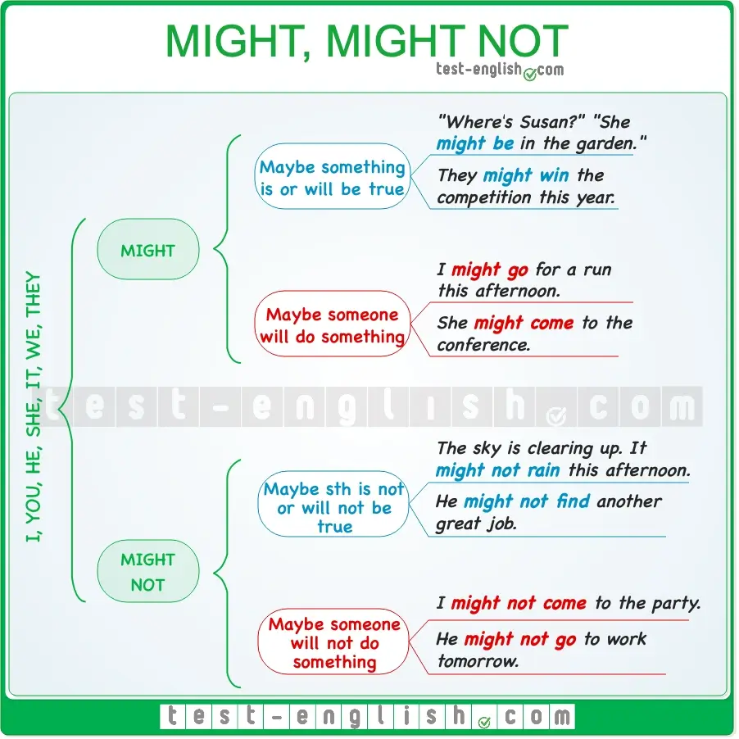

#### ****Might**** ****(not)****= Maybe it is (not) true

We use **might/might not** when we think something is (not) or will (not) be true, but we aren’t sure.

* ‘Suzan isn’t answering the phone.’ ‘She **might be** in the garden.’
* The sky is clearing up. It **might not rain** this afternoon.
* They **might win** the competition.

#### ****I might**** ****(not)****= It is possible that I will (not)

We say that **someone might do something** to mean that ‘it is **possible that someone will do something**‘.

* I **might go** for a run this afternoon. (=It’s possible that I will go for a run.)
* She **might come** to the conference.

We say that **someone might not do something** to mean that ‘it is **possible that someone won’t do something**‘.

* I **might not come** to the party. (=It’s possible that I won’t come to the party.)
* He **might not go** to work tomorrow.

## May, may not

#### May= might

We can use **may** and **may not**instead of **might** and **might not**.

* She **may be** late for class this morning.
* They **may not like** your decision.

#### May I…?

We don’t often use **might** or **may** in questions. However, we can use **may I** in questions to ask for permission.

* **May I sit** here? (=Can I sit here?)
* **May I come** in?

## May and might: What’s the difference?

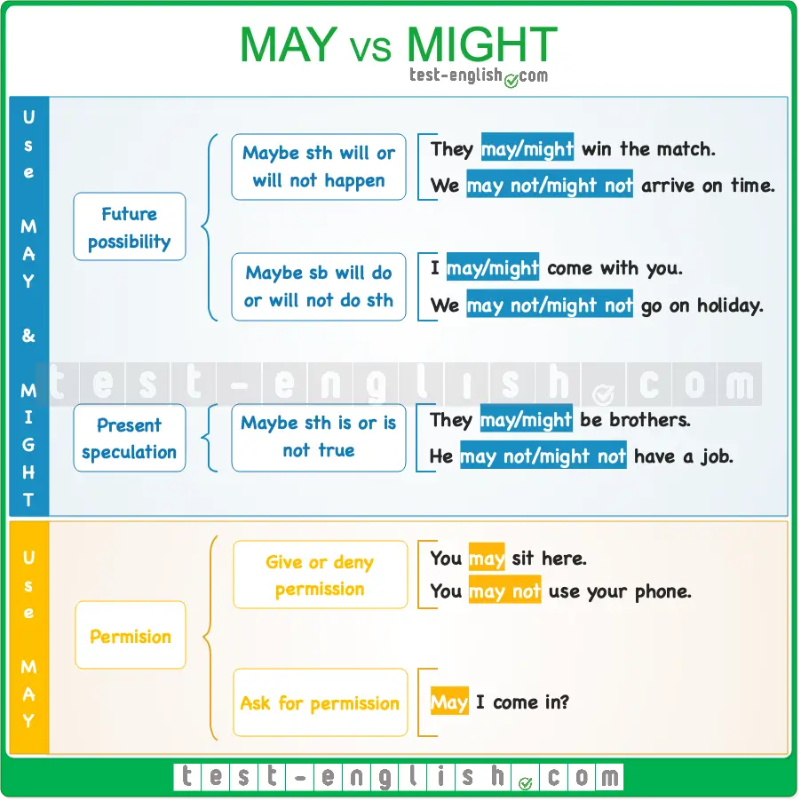

**May** and **might** are similar modal verbs that can often be used interchangeably, although with subtle differences in meaning. However, on some other occasions, only one of them can be used. In this lesson, we’ll help you understand their differences so that you can use them correctly.

### We can use both ****may**** and ****might****

#### To indicate possibility in the future

We can use **may** or **might** + infinitive to indicate **possibility in the future**: to say that maybe something will happen or someone will do something.

* It **may be** too late when we arrive.
* It **might be** too late when we arrive.

We use **may not** or **might not** + infinitive when we want to express **negative possibility in the future**: to say that maybe something will not happen or someone will not do something.

* I **may not go** on holiday this year.
* I **might not go** on holiday this year.

#### To speculate about the present

We can also use **may** or **might** + infinitive to speculate about the present: to say that maybe something is true.

* I think they **may be** sisters.
* I think they **might be** sisters.

We use **may not** or **might not** + infinitive to say that maybe something is not true in the present.

* He **may not be** home yet.
* He **might not be** home yet.

In everyday conversation, the difference between **may** and **might** when we express future possibility and when we speculate is very small, and many people use them interchangeably. However, using **may** instead of **might** suggests a stronger possibility that something will happen.

### We use ****may**** and NOT ****might****

#### To give, deny, or ask for permission

We use **may** and **may not** to give and not give someone permission to do something. **Might** is not used in this context.

* You **may sit** anywhere you like. 
* You **might sit** anywhere you like. 
* You **may not use** your phones in the classroom. 
* You **might not use** your phones in the classroom. 

We can also use **may**in questions to ask for permission.

* **May** I **ask** you a question?

While using **might** in this context is grammatically possible, it is not standard and sounds very unusual. **Might** is rarely or never used to ask for permission in modern English.

### Common mistake!

Note that after **may** or **might**, we use an infinitive without **to**.

* We **may/might to** visit you next summer. 
* We **may/might** visit you next summer. 
* She **may/might not to** arrive in time. 
* She **may/might not** arrive in time. 

## ****Used to, didn’t use to****: Grammar chart

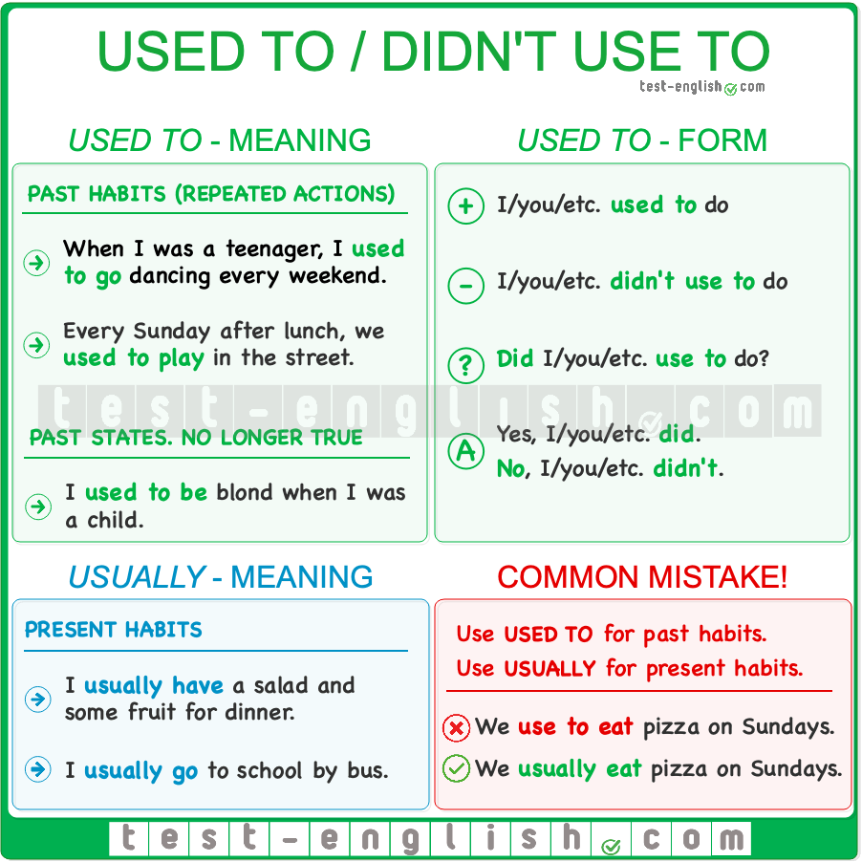

## ****Used to****

#### Past habits

We use **used to** to talk about **past habits**or things that **happened repeatedly** in the past but don’t happen any more.

* I used to play chess every day, but now I don’t play very often.
* When the economy was better, we used to eat **out** every week.

#### Past states

We use **used to** with non-action verbs (**be, have, etc.**) for **past states**: things that were true in the past but are not true any more.

* She used to be very shy when she was a child.
* I used to like her music, but now I hate it.

#### ****Didn’t use to, did you use to****?

We use **did**/**didn’t** + **use to** for negatives and questions.

* He **didn’t use to travel** a lot.
* ‘Did he use to live here?’ ‘Yes, he did.’

We can also use **never** for negatives

* We never used to argue.

## Past simple vs ****used to****

#### Past simple + ****always, usually, often****, etc.

We can also use the **past simple** tense + **frequency adverbs** for past habits.

* I always met her at the bar down the street. (= I used to meet …)
* I usually had a big salad for dinner. (= I used to have …)

#### Past simple (NOT ****used to****)

But we use the **past simple** (NOT **used to**) for actions that happened **once** or when we mention **when** they happened.

* Last week, I used to meet her at the bar down the street. 
* Last week, I met her at the bar down the street. 
* I used to have a big salad for dinner last Sunday. 
* I had a big salad for dinner last Sunday. 

## ****Usually**** or ****used to****?

**Used to** is only used in the **past**. To talk about **present habits**, we should use the **present simple** tense with **usually** or **normally**.

* I use **get up** very early at weekends. 
* I usually **get up** very early at weekends. 
* We don’t use to play on Sunday. 
* We don’t usually play on Sunday. 

## How to use verb ****go**** in English: Grammar chart

In the table below, you can see the different ways to use the verb **go** in English.  
  
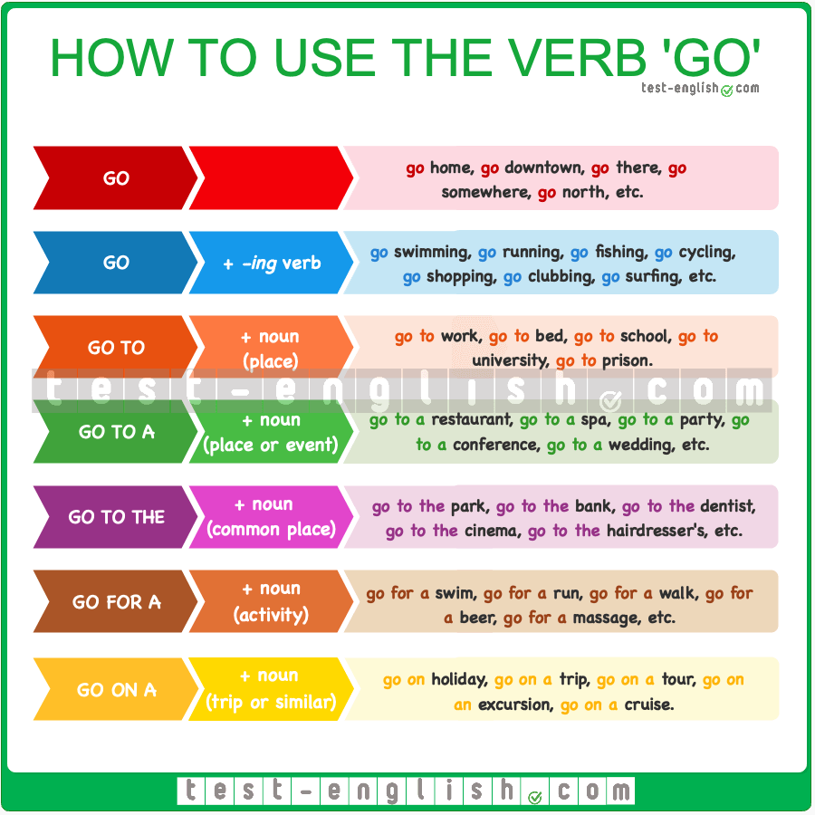

## Go + -ing

We use **go + -ing** verb for many sports, and also some other activities like **shopping, dancing, clubbing, etc.**

* I want to **go shopping** this afternoon.
* We **went kayaking** on Lake Michigan.

## Go to

#### Work/bed

We don’t use **the** in the expressions **go to work**and **go to bed**.

* What time do you **go to work**?
* I’m tired. I**‘m going to bed**.

#### School/university

We say **go to school** or **go to university** without **the** to mean that go to those places as students.

* They couldn’t **go to school** for a few days because of the snow.
* Almost 40% of young people **go to university**.

#### Prison

We say **go to prison** when someone is taken there as a prisoner.

* He could **go to prison** if the judge finds him guilty.

## Go to a/the

We use **go to a/the**+ nouns describing places or events. We use **go to + the** before nouns of places that we typically go in the city.

* I need to **go to the dentist**.
* I**‘m going to the bank**.

You can know when we use **a** or **the** by checking [the use of articles in English](https://test-english.com/grammar-points/a1/a-an-the-no-article/).

## Go for a

We use **go for a** before nouns describing acitivities, such as **a swim, a run, a walk, a ride, a drink, etc**.

* The weather is great today. I’m going to **go for a swim**.
* I have a new bike. Would you like to **go for a ride** with me?

## Go on a

We use **go on a** before nouns related to holidays, trips or similar, such as **holiday, trip, journey, excursion, tour, cruise, etc.**

* He **went on a cruise** with his family.
* Let’s **go on an excursion** to explore the area.

## The different uses of the verb ****get****

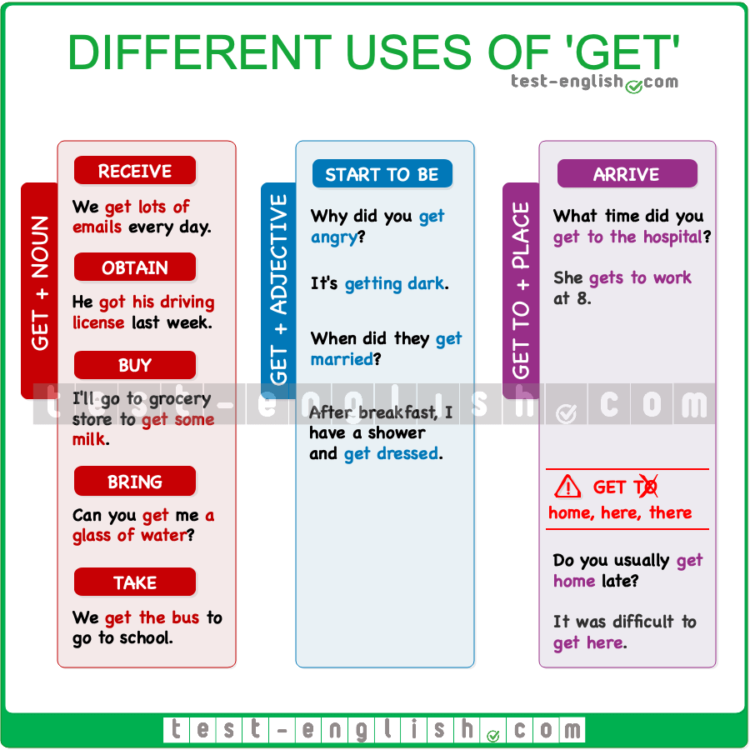

#### ****Get**** + noun: ****get an email, get a job, get a new TV, get the train, etc.**** (=receive, obtain, buy, bring, take)

* We **get lots of emails** every day.
* My son **got his driving license** last week.
* Did you **get a present** for Tommy’s birthday?
* ‘How did you go to Pam’s house?’ ‘I **got a train**.’

#### ****Get**** + adjective: ****get married, get hungry, get old, get tired, etc.**** (=start to be married/hungry/old/etc.)

* Why did you **get angry**?
* It**‘s getting dark**.
* When did they **get married**?
* After breakfast, I have a shower and **get dressed**.

#### ****Get to**** + place (=arrive)

* What time did you **get to the hospital**?
* She **gets to work** at 8.
* It was difficult to **get here**.
* Do you usually **get home** late?

❗ **Note** that we say **get here**, **get there** and **get home** (WITHOUT **to**).

## Do vs Make: What’s the difference?

**Do** and **make** are two English verbs which are often confused. There are, however, some important differences which can help us choose the right verb.  
  
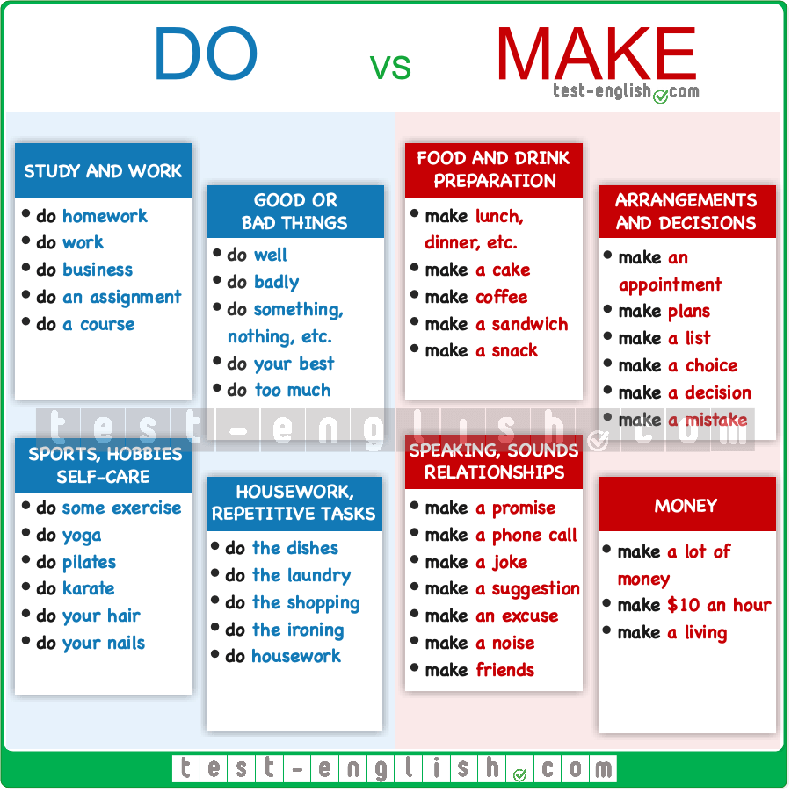

### When to use ****do****

We use **do** in collocations associated with **tasks**, **duties**, **obligations**, and **routine** or **repetitive** activities. **Do** usually refers to the **action** of performing these activities, while **make** generally refers to the **result**.  
  
**Do** is usually used in collocations referring to the following topics:  
  
➟ Study and work:

* do homework: I’ll do my homework after dinner.
* do work: Joe does a lot of work in the evenings.
* do business: They are **doing business** in Japan.
* do an assignment: I **did my assignment** last weekend.
* do a course: I am doing a photography course.

➟ Housework and repetitive tasks:

* do the dishes: I do the dishes every evening.
* do the laundry: Alice does the laundry when she gets home.
* do the shopping: I’ll do the shopping after work.
* do the ironing: Lee **is doing the ironing** right now.
* do housework: She does the housework at the weekends.
* ❗ **But** make your bed: I **make my bed** every morning.

➟ Good or bad actions:

* do well: He did well in his exams.
* do badly: I did badly in the race.
* do something, nothing, etc.: They did something exciting last weekend.
* do your best: He did his best to pass the exam.
* do too much: Rita does too much for her children.

➟ Sports, hobbies, and self-care:

* do exercise: You should do more exercise.
* do yoga: Anna does yoga twice a week.
* do karate, judo, etc. (martial arts): Bill **does karate** in the evenings.
* do your hair: I have a shower, I **do my hair,** and I get dressed.
* do your nails: Lara **did my nails** last weekend.

### When to use ****make****

We often use **make** when we talk about the creation or production of something. **Do** usually refers to the action, to the process of doing something, whereas **make** refers to the result of that action. For example, if you make dinner, the result is pasta.  
  
**Make** is usually used in collocations referring to the following topics:  
  
➟ Food and drink preparation:

* make lunch, dinner, etc.: I**’ll make lunch** soon.
* make a cake: He **made a cake** to take to the party.
* make coffee: Tim **makes coffee** for his wife every morning.
* make a sandwich: I **made a sandwich** to take to work.
* make a snack: Sid was hungry, so he **made a snack**.

➟ Arrangements and decisions:

* make an appointment: I **made an appointment** to see the doctor.
* make plans: We **are making plans** for the weekend.
* make a list: I **made a list** of the things I needed to buy.
* make a choice: Ian had to **make a difficult choice**.
* make a decision: It took me a long time to **make a decision**.
* make a mistake: I **made a mistake** in the exam.

➟ Speaking, sounds and relationships:

* make a promise: Jess **made a promise** to her grandmother.
* make a phone call: I need to **make a phone call**.
* make a joke: He **made a joke** about his sister’s new hairstyle.
* make a suggestion: The teacher **made a good suggestion**.
* make an excuse: He **made an excuse** to his teacher.
* make a noise: The neighbours **were making a lot of noise**.
* make friends: She **made friends** quickly at her new school.

➟ Money:

* make a lot of money: He **makes more money** than I do.
* make $10: Fred **makes $10 an hour** in his part-time job.
* make a living: She **makes a living** as a yoga teacher.

## Verbs with two objects: Grammar chart

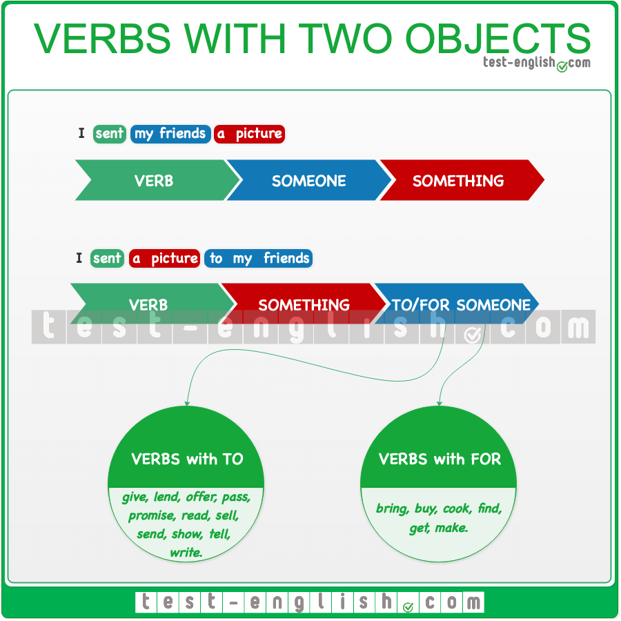

## Direct and indirect objects

The direct object typically answers the question of ‘what’ or ‘who’.

* I bought **a nice sweater**.
* **What** did you buy?
* I saw **Peter and Sarah**.
* **Who** did you see?

The indirect object typically answers the question ‘to whom’ or ‘for whom’.

* I sent **my friends** a picture of the house.
* **Who** did you send a picture **to**?
* I cooked my wife breakfast.
* **Who** did you cook breakfast **for**?

## Verbs with two objects

There are some verbs which have two objects: an indirect object and a direct object.  
  
Some of these verbs are:

**bring, buy, cook, find, get, give, lend, make, offer, pass, promise, read, sell, send, show, tell,** and **write**.

After these verbs, there are two possible structures:

‣ I sent my friends a picture.

‣ I sent a picture to my friends.

If the indirect object is a [pronoun (me, you, him, her, etc.)](https://test-english.pro/grammar-points/a1/object-pronouns/), we normally use it next to the verb.

‣ I sent them a picture.

#### ****To**** or ****for****?

When we use the indirect object next to the verb, we do not use **to** or **for**.

* I send **to Alex** a postcard. 
* I send **Alex** a postcard. 

We use **to** or **for** in: verb + direct object + **to/for** + indirect object.

* I sent a postcard **to** Alex.
* She bought a present **for** her friend.

Some verbs are used with **to**, and some other verbs are used with **for** before the indirect object.

#### ****To**** + indirect object

Some common verbs that are used with **to**+ indirect object are **give, lend, offer, pass, promise, read, sell, send, show, tell,** and **write**.

* You should give an apology **to** Tom.
* She showed the letter **to** all her friends.

#### ****For**** + indirect object

Some common verbs that are used with **for** + indirect object are **bring, buy, cook, find, get,** and **make**.

* Can you bring some food **for** the dog?
* I’ll cook a nice dinner **for** you.

## Stative Verbs

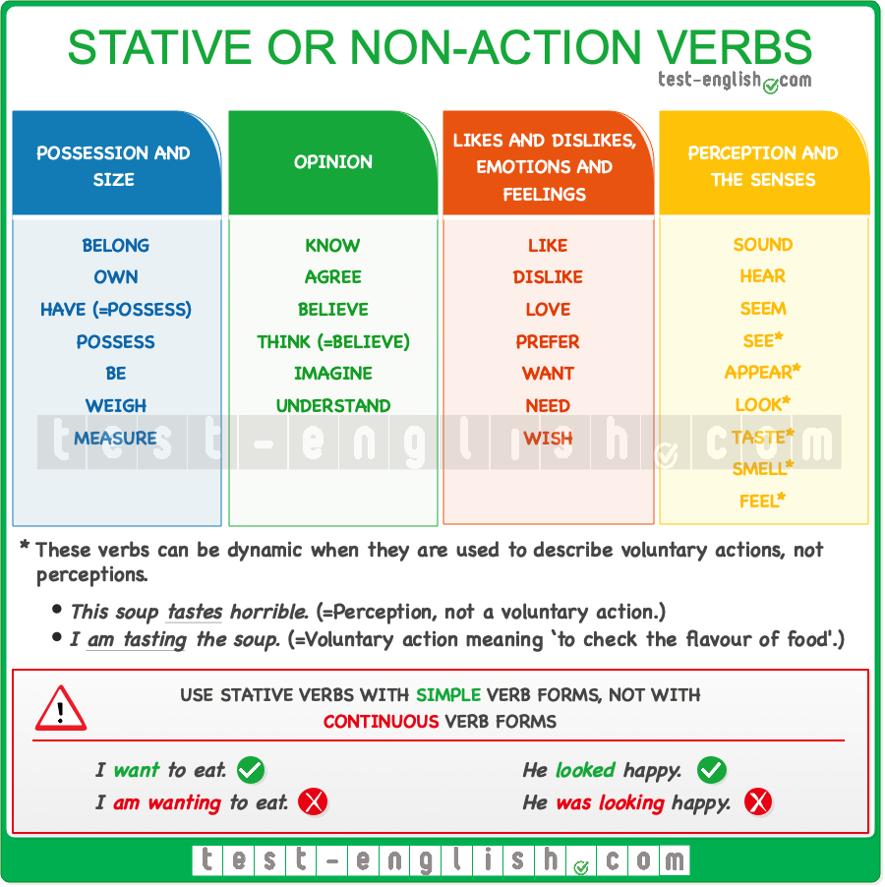

**Stative** or **non-action** verbs are verbs that describe a **state** or **condition** rather than an action. As a state has no real beginning or end, stative verbs are only used with **simple** and **perfect** tenses. They cannot be used with **continuous** tenses.  
  
These are some of the **most common** verbs that refer to states or conditions, so they are **stative verbs**.

#### Possession and size.

Examples: **belong, own, have** (meaning ‘possess’)**, possess, weigh, measure**.

* Ali **owns** three cars. 
* Ali is owning three cars. 

#### Opinion

Examples: **know, believe, agree, think** (meaning ‘believe’ or ‘have an opinion’)**, imagine, understand**.

* I **know** what the answer is. 
* I **am** **knowing** what the answer is. 

#### Likes and dislikes, feelings and emotions.

Examples: **like, love, want, need, wish, prefer, dislike**.

* Sam **likes** vegetables. 
* Sam is liking vegetables. 

#### Perception and the senses.

Examples: **sound, hear, seem, see*, appear*, look*, taste*, smell*, feel\***.

* You **sound** sad. 
* You are sounding sad. 

**\*** Although they are usually used as **stative** verbs, these verbs can also be **dynamic** when they are used to describe **voluntary actions**, not perceptions.

## Dynamic Verbs

**Dynamic verbs** describe an **action**, **change**, or **process** with a beginning and an end. They are the most common type of verb and can be used in all tenses and aspects.

When referring to an action that is or was in progress, we use **dynamic** verbs with a **continuous** tense.

* I am eating breakfast now.

However, when referring to habits or things that are always true, we use them with a **simple** tense.

* I eat breakfast at the same time each day.

Here are some common verbs that refer to actions, not states, so they are **dynamic** and can be used in both **simple** and **continuous** tenses:

**eat, run, swim, speak, talk, walk, sleep, make, cook, come, go, buy, sit, watch, listen, do, play, say, read, write, stand, bring, take, give, jump, drive, ride, climb, fly, fall, cry, drink, send, kiss, wear, smell*, taste*, feel*, look\***.

**\*** These are often **stative verbs**, but they can be used in continuous forms when they are **voluntary actions**.

## Verbs which are both stative and dynamic

Some verbs can be both **stative** and **dynamic**. Here are some common examples.

#### ****Have****

**Have**, meaning ‘to possess’, describes a state, so it is a **stative** verb.

* I **have** two cats.

**But** when **have** doesn’t mean ‘to possess’, it describes an action, so it is a **dynamic** verb.

* They are **having** a party on Saturday.
* I **was having** dinner when someone knocked at the door.

#### ****Be****

The verb **be**is normally used to describe a state, so it is a **stative** verb.

* James **is** a doctor.

But when **be** means ‘to act or behave’, it describes an action, so it is a **dynamic** verb.

* He **is being** very kind to us.

#### ****Think****

**Think**, meaning ‘to believe’ or ‘to have an opinion’, describes a state, so it is a **stative** verb.

* I **think** it is a good idea.

**Think**, meaning ‘to use your brain to reflect”, is an action, so it is a **dynamic** verb

* Sara **is thinking** about her boyfriend.

#### ****Look****

**Look**, meaning ‘to appear’, is a state, so it is a **stative** verb.

* Tom **looks** like his sister.

**Look**, meaning ‘to focus the eyes on something’, is an action, so it is a **dynamic** verb.

* Peter **is looking** out the window.

#### ****Taste, see, smell, feel****

Although they are usually classified as **stative**, some verbs of the senses (e.g., **taste, see, smell, feel**) can also be **dynamic** when they refer to **voluntary actions** and not perceptions.

* This soup **tastes** horrible. (=Perception, not voluntary.)
* I **am tasting** the soup. (=Voluntary action meaning ‘to put food in your mouth to see how it tastes’.)
* I **saw** a man looking through a window. (=Not voluntary)
* Tom **is seeing** Katie this afternoon. (Voluntary action meaning ‘to meet or visit someone’)

## Phrasal verbs: transitive and intransitive, separable and inseparable

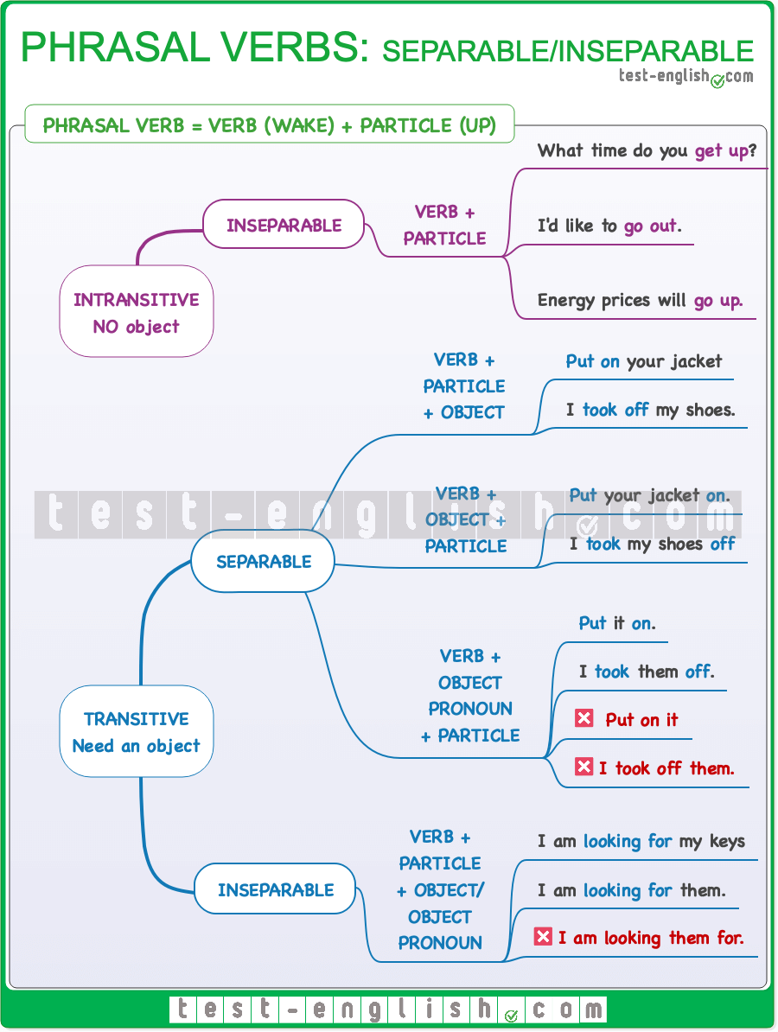

**Phrasal verbs** consist of a **verb + a preposition or an adverb**. When we add the preposition or the adverb to the verb, the original meaning of this verb changes. The adverb or preposition that we add to the verb is called the ‘**particle**‘. Verb + particle = **phrasal verb**.

‣ wake + up = **wake up**  
‣ sit + down = **sit down**  
‣ throw + away = **throw away**  
‣ pick + up = **pick up**  
‣ take + off = **take off**

Some phrasal verbs consist of a **verb + two particles**; for example:

* I am **looking forward to** my holiday.
* I **get on with** my father.

### Transitive and intransitive verbs

**Transitive verbs** are verbs that **need an object**. The object is the receiver of the action, and it goes after the verb. For example, in the sentence “I bought a T-shirt”, the verb is “buy”, and “a T-shirt” is the object because it tells us what was bought. If you use a transitive verb without an object, the verb does not make sense because it needs an object; for example:

* I **bought**. 
* I **bought a T-shirt**. 
* They **wrote**. 
* They **wrote a letter**. 

**Intransitive verbs**, on the other hand, are verbs that **do not have an object**. They describe an action or occurrence that does not involve a direct object. Here are a few examples of intransitive verbs:

* He **slept**.
* She **laughed**.
* They **danced**.

The action described by these verbs is NOT done to anything or anybody; we do NOT **\*sleep something**; we just **sleep**.

### Intransitive phrasal verbs – Inseparable

As we said, **intransitive phrasal verbs** have **no object**, and this means the verb and the particle are always together; they cannot be separated. For this reason, intransitive phrasal verbs are called **inseparable**. Here are some examples:

* I like to **get up** late.
* Joe isn’t here. He’s **gone out**.
* The price of oranges has **gone up**.

### Transitive phrasal verbs – Separable

**Transitive phrasal verbs** need **an object**, and they can be **separable** or **inseparable**. When a phrasal verb is separable, we can use either **verb + particle + object** or **verb + object + particle**.

* You need to **put on** your jacket. 
* You need to **put** your jacket **on**. 
* I **took off** my shoes. 
* I **took** my shoes **off**. 

We can also replace the object with a **pronoun**, but then the object MUST go **between the verb and the particle**.

* You need to **put it on**. 
* You need to **put on it**. 
* I **took them off**. 
* I **took off them**. 

### Transitive phrasal verbs – Inseparable

Some other **transitive phrasal verbs** can NEVER be separated, even if the object is replaced by a **pronoun**.

* I am **looking for my notebook**. 
* I am **looking for it**. 
* I am **looking my notebook for**. 
* I am **looking it for**. 

### Examples of each type of phrasal verb:

#### Intransitive phrasal verbs (Always inseparable).

* COME BACK: Jim **is coming back** from Italy soon.
* GET ALONG: My sister and I **get along** very well.
* GO AWAY: I told him to **go away**.
* GROW UP: He needs to **grow up**.
* HURRY UP: Please **hurry up**!
* STAND UP / WALK AWAY: I **stood up** and **walked away**.

#### Transitive separable phrasal verbs

* FILL IN: We **filled** our forms/them **in**. | We **filled in** our forms.
* LOOK UP: I **looked** the word/it **up**. | I **looked up** the word.
* PAY BACK: I **paid** the money/it **back**. | I **paid back** the money.
* THROW AWAY: I **threw** the bread/it **away**. | I **threw away** the bread.
* CALL OFF: They **called** the concert **off**. | They **called off** the concert.
* TRY ON: I **tried** the dress/it **on**. | I tried on the dress.
* TURN ON: Please **turn** the light/it **on**. | Please **turn on** the light.
* TURN UP/DOWN: Can you **turn** the music/it **up**? | Can you **turn up** the music?
* WRITE DOWN: I **wrote** his name/it **down**. |  I **wrote down** his name.

#### Transitive inseparable phrasal verbs

* GET ON WITH: I don’t **get on with** my brother/him.
* LOOK AFTER: I **looked after** the children/them.
* LOOK FOR: He is **looking for** his keys/them.
* SEARCH FOR: I **searched for** my ring/it.
* TAKE CARE OF: She **takes care of** the garden/it.

### Conditionals, ****if****, ****wish****, etc.

## First conditional: Grammar Chart

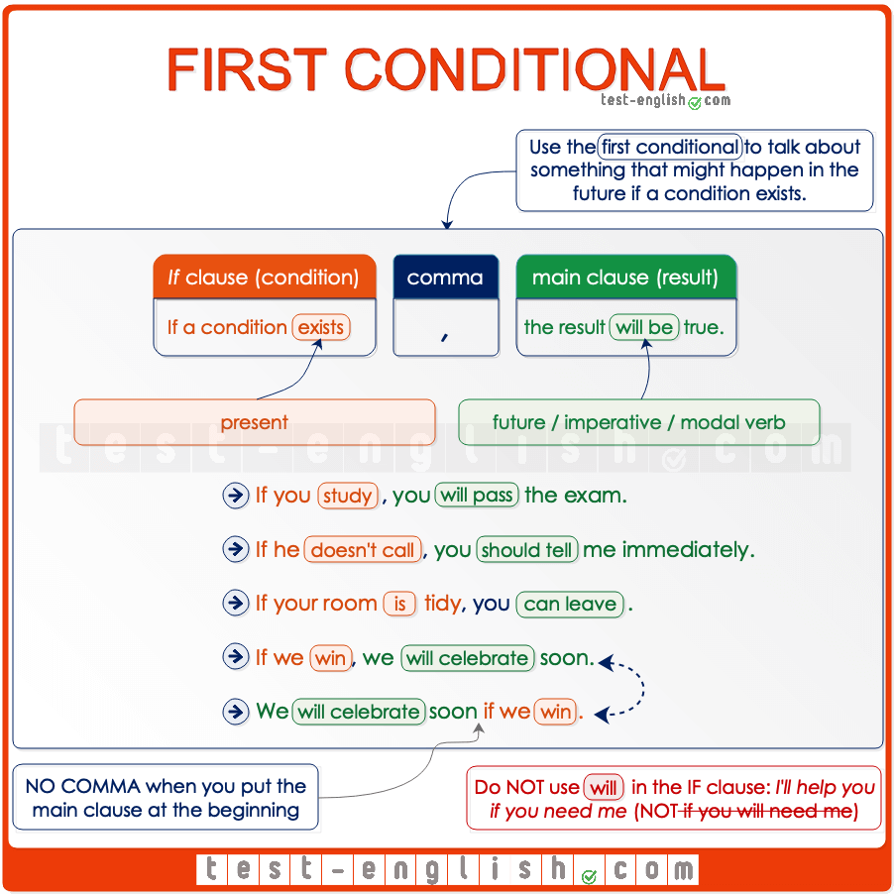

#### ****If**** clause and main clause

All conditional sentences have two parts: the **if** **clause** and the **main clause**. It doesn’t matter which clause comes first, but when the **if clause** comes first, we should put a **comma** after it.

* If it rains**,** we’ll stay home
* We’ll stay home **if** it rains.

#### ****If**** + present, future

In the first conditional, the verb in the **if** **clause** is **present**, and the verb in the **main clause** is future.

* If you **don’t go** to sleep, you’**ll be** very tired tomorrow.

The ****if clause****may have a present or a future meaning, but the **verb** is **always** **in the present** (NOT future)

* If you **will be** a good boy tomorrow, mummy will buy you a present. 
* If you **are** a good boy tomorrow, mummy will buy you a present. 

#### Main clause: ****will****, modal verb, imperative

In the **main clause**, we can also use **may, might, can, must, should** instead of **will**.

* If he doesn’t train harder, he **may/might** lose the championship.
* If your room is tidy, you **can** leave.
* If you want to lose weight, you **must/should** eat less sugary things.

We can also use an **imperative** instead of **will**.

* If you arrive after midnight, **ring** me on my mobile.

## Future time clauses – Grammar Chart

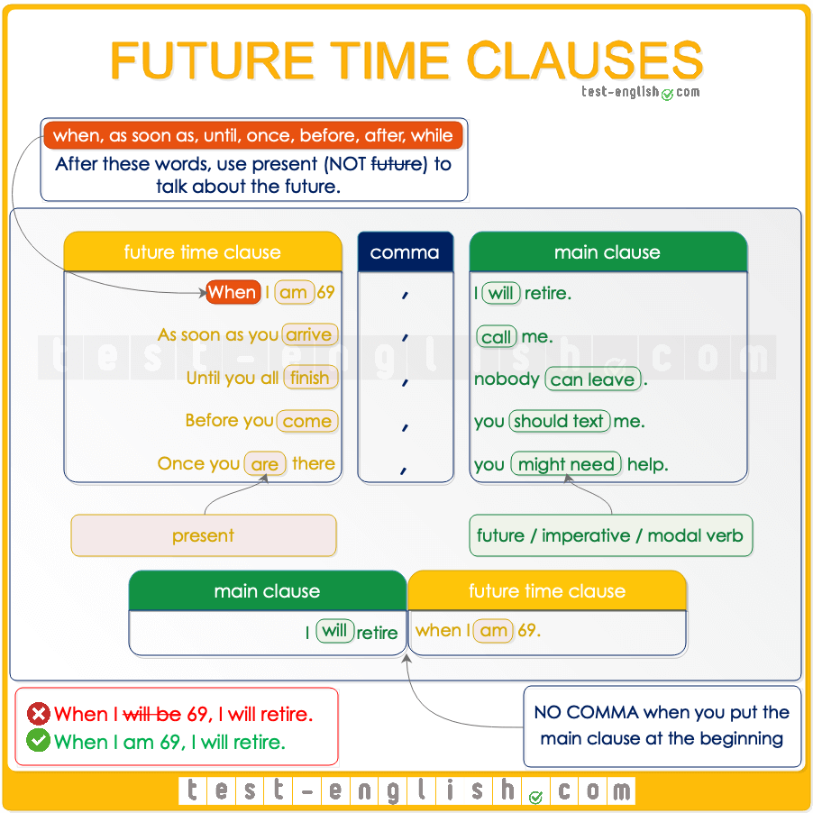

#### ****When, as soon as, before, after, until****

When we use a verb after **when, as soon as, before, after** or **until** to talk about the future, we have to use this verb in the present tense (NOT future). We use the future in the other part of the sentence.

* I’ll retire when I **will be** 70. 
* I’ll retire when I**‘m** 70. 
* I won’t call you until I **will** arrive. 
* I won’t call you until I arrive. 

#### Similar to the first conditional

Future time clauses are similar to the first conditional. There’s a **main clause** and a **when/after/etc. clause**. We use the verbs in these clauses like in the first conditional.

We use a comma when the **when/after/etc. clause** is at the beginning of the sentence. But we don’t use a comma if the **when/after/etc. clause** is at the end of the sentence.

* I’ll retire when I’m 70.
* When I’m 70**,** I’llretire.

We use the present in the **when/after/etc. clause**, and we use the future in the **main clause**.

* Before you go to sleep, Daddy will tell you a story.

In the **main clause**, we can also use **may, might, can, must, should** or an **imperative** instead of **will**.

* As soon as you finish, you can leave.
* After you arrive, call me.

## Second conditional: Grammar chart

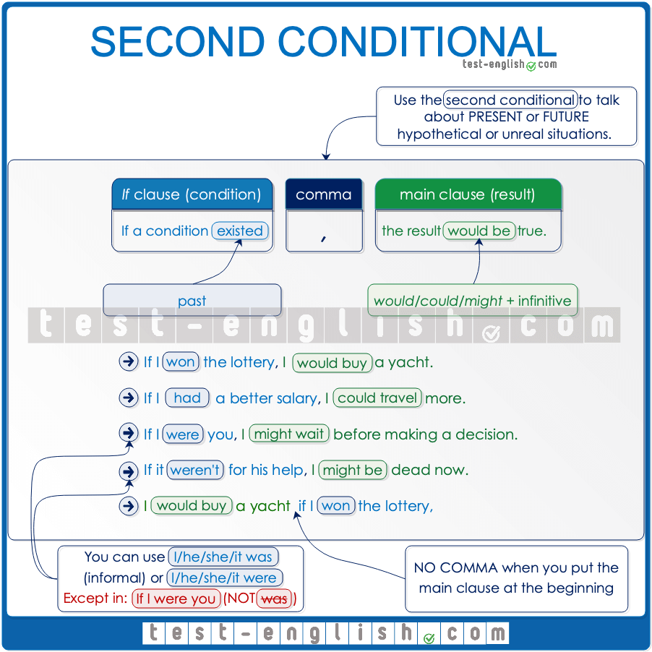

### ****If**** clause and main clause

We use **if** + **past** to talk about an imaginary present or future situation (although the verb is in the past, the meaning is present or future). And we use **would** + **infinitive**to talk about the result or consequence of that imaginary situation.

* If we **had** a mansion in the country, we’**d go** there every weekend.
* **Would** you **travel**around the world if you **won** the lottery?

### Comma

When the **if** **clause** comes first, we usually put a **comma** after it. We don’t use a comma when the **main clause**comes first and the **if clause**comes second.

* If I won the lottery**,** I’d buy a mansion.
* I’d buy a mansion **if** I won the lottery.

### ****Would****

**Would/wouldn’t**is the same for all persons.

* I/you/he/she/it/we/they **would/wouldn’t do** that if it was possible.

Contracted forms are **wouldn’t**= **would not** and **‘d**= **would**

* I**‘d** never tell anyone if you told me your secret.
* I **wouldn’t** tell anyone if you told me your secret.

### ****Could****

We can often use **could** + **infinitive** instead of **would** + **infinitive** in the main clause.

* If you spoke English, you **could get** a better job.

### ****Was**** or ****were****?

In the second conditional, we can use **if I/he/she/it were** (more formal) instead of **if I/he/she/it was** (spoken English).

* If **I** **were/was** fit, I would run a marathon.
* We wouldn’t have any problems **if** **he were/was**more reasonable.

But we use **were** (NOT **was**) when we give advice with the expression **if I were you**.

* If I were you, I would stay home and rest.
* I wouldn’t pay any attention to what he says **if I were you**.

## First conditional vs Second conditional

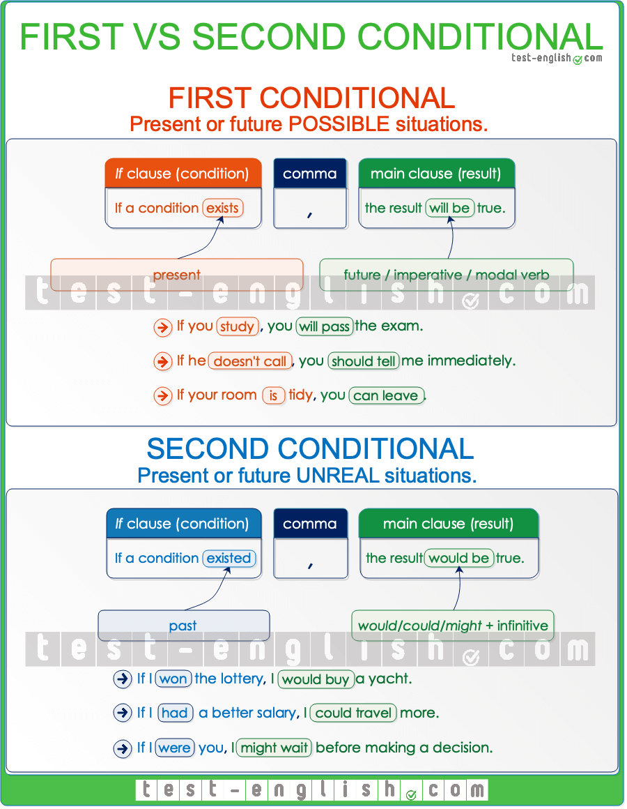

We use the **first conditional** to talk about **possible** future situations and the **second conditional** to talk about **hypothetical** or **imaginary** future situations.

* If I **don’t have** a meeting tomorrow morning, I’**ll have** lunch with you. (It’s possible. Maybe I don’t have a meeting.)
* If I **didn’t have** a meeting tomorrow morning, I’**d have** lunch with you. (It’s hypothetical. I have a meeting tomorrow, so I won’t be able to have lunch with you.)

### Passive

## Present and past simple passive: Grammar chart

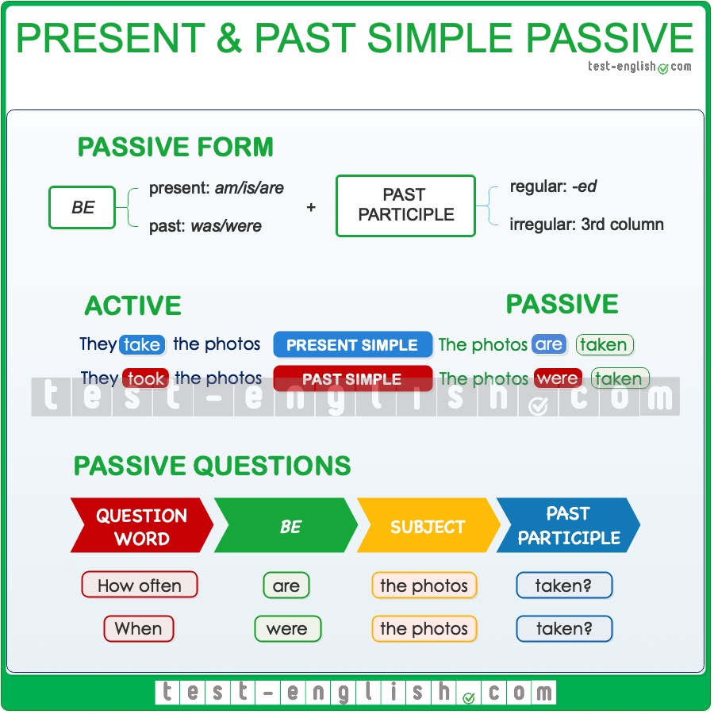

## Active sentences vs passive sentences

When **A does B**, we have two possible ways of talking about it: **active** or **passive.** In active sentences, **A is the subject** (before the verb). In passive sentences, **B is the subject**. Check the following examples:

#### Present simple

‣ Somebody cleans the classroom every day. (Active)

‣ The classroom is cleaned every day. (Passive)

#### Past simple

‣ Somebody cleaned the classroom yesterday. (Active)

‣ The classroom was cleaned yesterday. (Passive)

As you can see, the object of an active sentence is the subject of a passive sentence. In an active sentence, the subject is the ‘doer’ of the action, and the object is the ‘receiver’ of the action. In a passive sentence, the subject is the receiver of the action, NOT the doer. Compare:

* **Somebody** broke the window.
* **The window** was broken (by someone).

In the first sentence, ‘somebody’ is the doer of the breaking, and in the second sentence, ‘the window’ is the receiver of the breaking.

## When do we use the passive?

The passive is more formal than the active, and it is more common in written language. We often use the passive when we don’t know, when it is obvious, or when we don’t want to say who or what is responsible for the action.

* A bank **was robbed** yesterday. (We don’t know who robbed the bank.)
* The robber **was arrested**last night. (It’s obvious that the police arrested the robber.)
* I **was told** that you insulted my brother. (I don’t want to say who told me.)
* Jurassic Park **was filmed** by Spielberg in 1993. (I’m talking about Jurassic Park and not about Spielberg.)

## Passive voice + ****by****

We can use **by**to say who or what is responsible for the action.

* The painting was bought **by a very rich American**.
* Penicillin was invented **by Alexander Fleming**.

### Reported speech

## What is reported speech or indirect speech?

When we tell people **what another person said or thought**, we often use **reported speech** or indirect speech. To do that, we need to change verb tenses (present, past, etc.) and pronouns (**I, you, my, your, etc**.) if the time and speaker are different.

* Sally: ‘**I** **don’t have** time.’ ⇒ Sally said that **she didn’t have** time.
* Peter: ‘**I am** tired .’ ⇒ He said that **he was** tired.

## Omission of ****that****

We often leave out **that** after reporting verbs like **say, think**, **etc.**

* She **said she** was late. (=She said that she was late.)
* I **thought I** would get the job.

## ****Say**** or ****tell****?

The most common verbs we use in reported speech are **say** and **tell**. We must pay attention here. We say **tell somebody** **something** and **say something (to somebody)**.

* They **said me** (that) they would help me. 
* They **told me** (that) they would help me. 
* He **told** (that) he didn’t have a car. 
* He **said** (that) he didn’t have a car. 

## Tense changes in reported speech

When a person said something **in the past**, and **now** we tell somebody what that person said, the time is different, and for this reason, the verb tenses change. Look at a summary of these changes.  
  
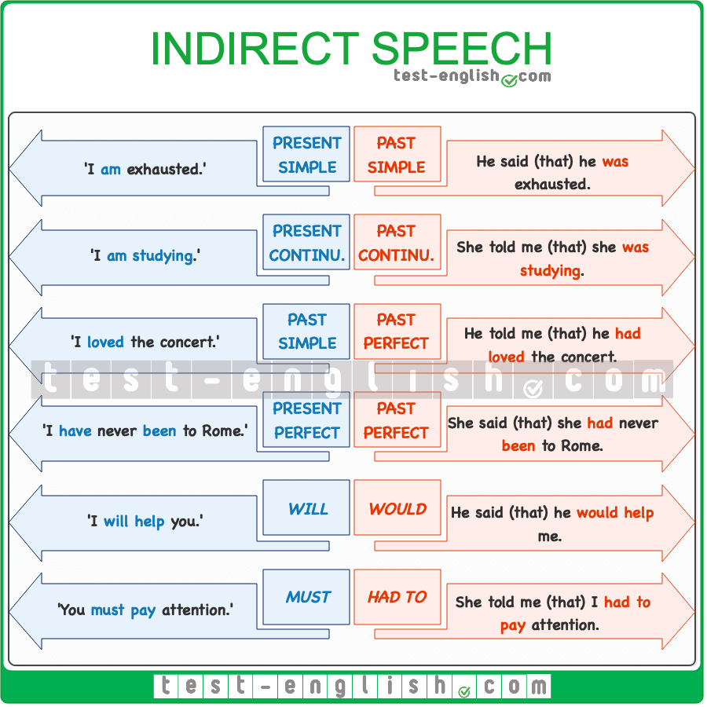

## Pronoun changes in reported speech

In reported or indirect speech, we must also pay attention to the use of pronouns. When a person tells us something, he or she uses the first person (**I, me, my, we, us, our**) to talk about himself or herself and the second person (**you, your**) to talk about us, the person listening. But when we tell someone else what that person said, we are going to use the third person (**he, she, his, her, etc.**) to talk about the speaker and the first person (**I, me, my**) to talk about ourselves, the listener.

* ‘**I** will help **you**.’ ⇒ He said that **he** would help **me**.
* ‘That’s **my** pen.’ ⇒ She said that it was **her** pen.
* ‘**I** need **your** help.’ ⇒ She said that **she** needed **my** help.

### -ing and the infinitive

## Expressing purpose with ****to**** and ****for****

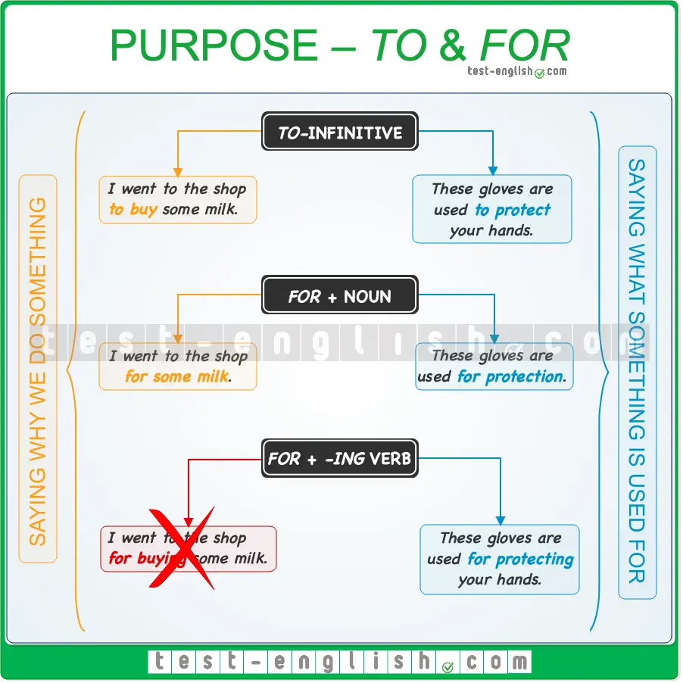

We can use **to** + infinitive and **for** + noun to talk about the purpose of an action or the reason why we do something.

### ****To**** + infinitive

* I went to the grocery store **to buy** some vegetables.
* I studied hard **to pass** the exam.

### ****For**** + noun

* Let’s go to the pub **for** a drink.
* We climbed to the top **for** the views.

#### Compare ****to**** vs ****for****

* I went to the shop **to buy** some milk.
* I went to the shop **for** some milk.

### ****For**** + ****-ing****

#### Don’t use ****for + -ing**** verb to talk about why we do something

We don’t use **for** + **-ing** verb to say what is the purpose of our actions, why we do something.

* I work hard **for improving** my English.
* I work hard **to improve** my English.
* Turn the TV on **for watching** the news.
* Turn the TV on **to watch** the news.

#### Use ****for + -ing**** verb to talk about the purpose or function of an object

We can use **to**+ infinitive or **for + ing** verb to talk about the purpose or function of a thing, what an object is used for.

* This machine is used **for cleaning** cars.
* This machine is used **to clean** cars.
* This is a special camera **for photographing** small objects.
* This is a special camera **to photograph** small objects.

## Infinitives and gerunds: Verb patterns

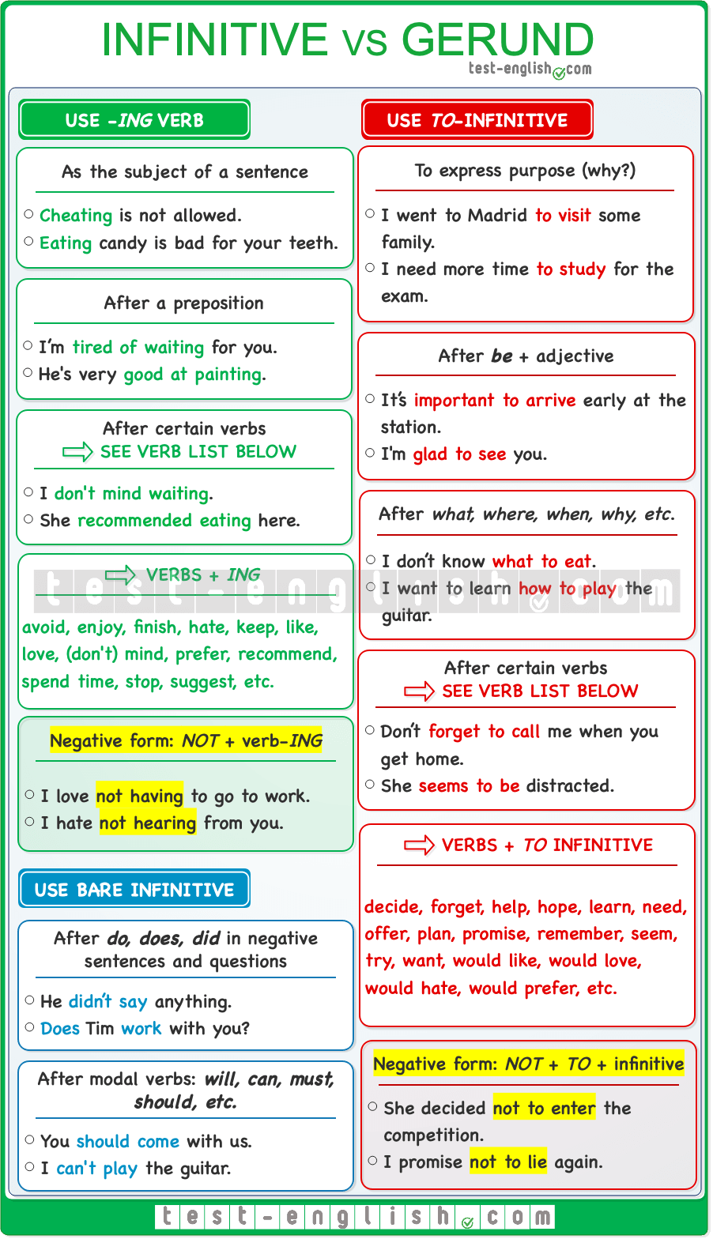

## Use gerund

➟ When the verb is the **subject** of a sentence.

* **Reading** on tablets and phones isn’t very good for your eyes.

➟ **After** a **preposition**.

* I’m tired **of waiting**. Let’s go home.

➟ After **some verbs**.

* I don’t **mind waiting**.
* She **recommended visiting** this museum.

#### Common verbs followed by a gerund

Some common verbs that are followed by a gerund are **avoid, enjoy, finish, hate, keep, like, love, don’t mind, prefer, recommend, spend time, stop, suggest, etc.**

#### Negative gerund

The negative form of the gerund is **not +** **-ing**.

* *He enjoys* ***not having*** *to wake up early at weekends.*

## Use infinitive without ****to****

➟ After the auxiliary verb **do**, **does**, **did** in negative sentences and questions.

* He **didn’t say** anything.
* **Does** Tim **work** with you?
* I **don’t believe** you.

➟ After modal verbs (**will, can, must, should, might, may,** **etc**.)

* You **should come** with us.
* I **can’t play** the guitar.

## Use ****to**** + infinitive

➟ After **adjectives**.

* It’s **important to arrive** early at the station.

➟ To express a reason or **purpose** (why).

* I went to Madrid **to visit** some family.
* I need time **to study** for the exam.

➟ After **question words**.

* I don’t know **what to eat**.
* I want to learn **how to play** the guitar.

➟ After **some verbs**.

* Don’t **forget to call** me.
* She **seems to be** distracted.

#### Common verbs followed by a ****to**** -infinitive

Some common verbs that are followed by a **to**–**infinitive** are **ask (someone), decide, forget, help, hope, learn, need, offer, plan, promise, remember, seem, try, want, would like, would love, would hate, would prefer, etc**.

#### The negative form of ****to****-infinitive

The negative form of **to** + infinitive is **not to** + infinitive.

* She decided **not to enter** the competition.

### Articles, nouns, pronouns, and determiners.

## ****Something, anything, nothing, etc.****: Grammar chart

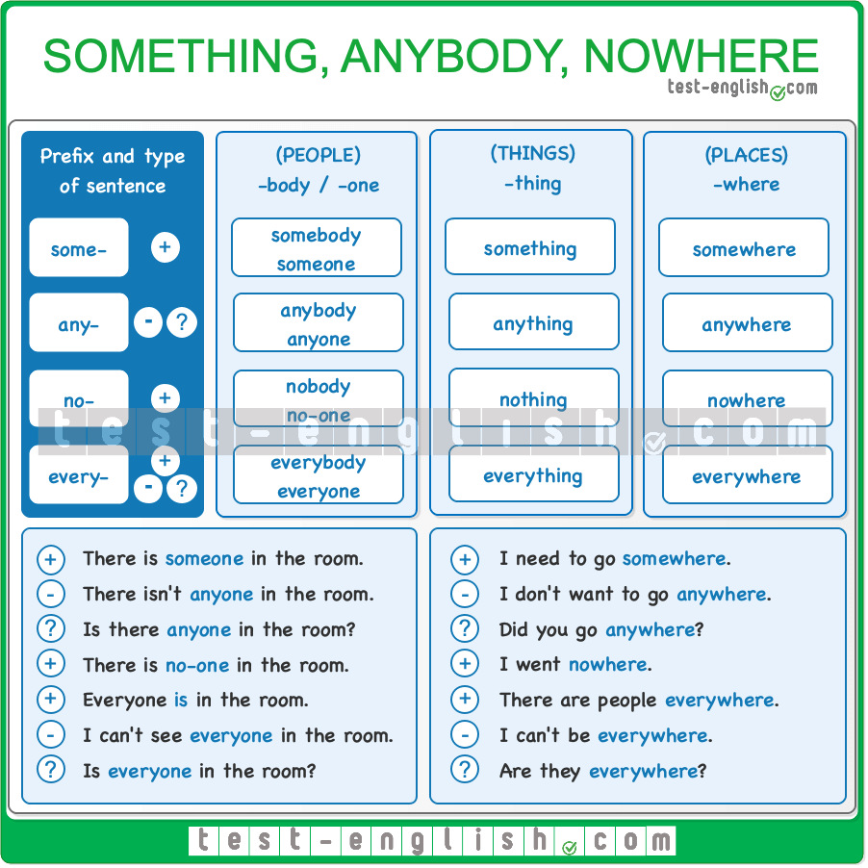

#### ****Some-**** in affirmative sentences

We usually use **something, somebody**/**someone**, **somewhere** in affirmative sentences.

* Look! There’s **something** under that chair.
* **Somebody** called you yesterday.

#### ****Any-**** in negative and interrogative sentences

We use **anything, anybody**/**anyone**, **anywhere** in negative sentences and questions.

* There isn’t **anybody** in the house.
* Is there **anybody** here?

❗ **But** we often use **something, somebody**/**someone**, **somewhere** in requests and in offers, i.e. when we ask for something or offer something to someone.

* Can **somebody** help me?
* Would you like **something** to eat?

#### ****No-**** with affirmative verbs

We use **nobody**/**no one**, **nothing**, **nowhere** in sentences with an affirmative verb.

* The sun was in my eyes, and I **couldn’t** see **nobody**. 
* The sun was in my eyes, and I could see **nobody**. 
* ‘Where have you been?’ ‘**Nowhere**.’

#### ****Every-**** means ‘all’

We use **everybody**/**everyone**, **everything**, **everywhere** when we mean ‘all the people’, ‘all the things’ or ‘(in) all the places’.

* ‘**Everybody** in my class has passed the exam.’
* ‘From the top of the mountain, we could see **everything**.’
* ‘There were insects **everywhere**.’

#### Singular verbs

We use singular verbs with all these words.

* **Everything** is expensive nowadays.
* **Everyone** was tired.
* Has **anyone** seen my glasses?

#### ****Something, anyone, nowhere, etc.**** + adjective

We can use an adjective (**nice,** **wrong**, etc.) after **something**, **anything**, etc.

* Can’t we go **somewhere quiet**?
* I didn’t do **anything wrong**.

#### ****Something, anyone, nowhere, etc.**** + ****to**** infinitive

We can use **to** + infinitive after **something**, **anything**, etc.

* We didn’t have **anywhere to go**.
* I need **something to do**.  I’m bored.

## Much, many, little, few, some, any: Grammar chart

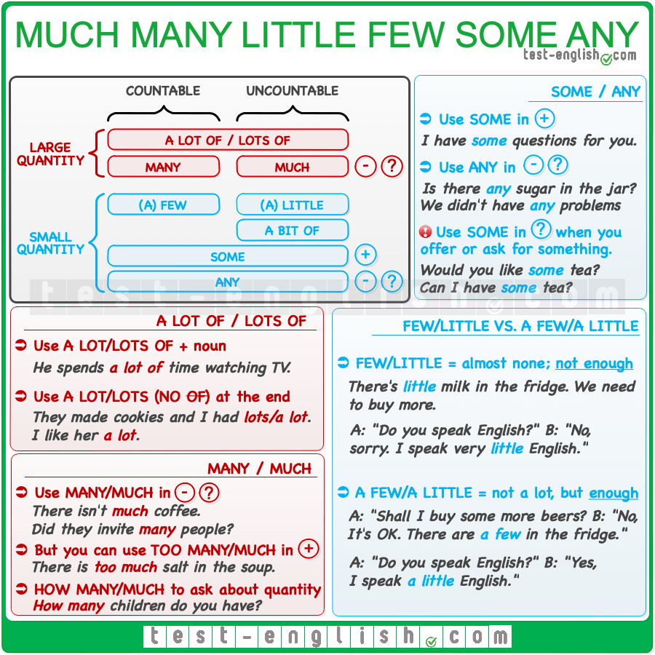

## Many/much

#### ****Many**** for countable, ****much****for uncountable in (?) (-)

We use **many** before **plural** (countable) nouns and **much** before **uncountable** nouns. We use them in **negative** sentences and **questions**. We don’t normally use them in affirmative sentences.

* There isn’t **much coffee** in the jar.
* Were there **many people** in the party?

#### Too much/too many

🔍 **Note** that we don’t normally use **much**/**many** in affirmative sentences, but we can use **too much** and **too many** in affirmative sentences.

* There’s **too much salt** in the soup.
* You eat **too many biscuits**.

#### How much/how many

We use **how many** and **how much** to ask about quantity.

* **How many concerts** have you ever been to?
* **How much coffee** have you had today?

## A lot of/lots of

#### Before both countable and uncountable

We use **a lot of** or **lots of** (more informal) before both **plural** (countable) and **uncountable** nouns. We normally use them in positive sentences.

* She spends **a lot of time** watching TV.
* We had **lots of good** moments together.

#### ****Of****before noun but NOT at the end of sentence

We must always use **a lot of** or **lots of** including **of** before a noun. However, we can use the expressions **a lot** or **lots** (without **of**) at the end of a sentence.

* ‘How many beers did you have?’ ‘I don’t know; I had **lots/a lot**.’
* I like her **a lot**.

## (A) few/(a) little/a bit of

#### ****Few**** for countable; ****little**** for uncountable

We use **(a) few** before **plural** (countable) nouns and **(a) little** or **a bit of** (more informal) before **uncountable** nouns.

* I have to do **a few things** this afternoon.
* He always gets good results with very **little effort**.
* Can you put **a bit of sugar** in the tea?

#### ****Few**** or ****a few****? ****little**** or ****a little****?

**A few** means ‘some but not many; enough’, and **a little**means ‘some but not much; enough’.  
  
**Few/little**mean ‘almost none; not enough’.  
  
Normally, the difference between **a few/little** (WITH **a**) and **few/little** (WITHOUT **a**) is that **a few/little** is positive in meaning, and **few/little** is negative. Compare:

* There’s **little milk** in the fridge; we have to buy more. (Not enough; we need more)
* ‘Shall I buy some beers?’ ‘No, it’s OK, there are **a few** in the fridge.’ (=Enough; we don’t need more)
* ‘Do you speak English?’ ‘**No**, I speak very **little English**.’ (=Negative)
* ‘Do you speak English?’ ‘**Yes**, I speak **a little English**.’ (=Positive)

## Some/any

#### ****Some**** in (+); ****any**** in (?) (-)

We use **some** in **affirmative** sentences and **any** in **negative** sentences and **questions**.

* Is there **any sugar** in the cupboard?
* Have you got **any new friends**?
* I have **some questions** to ask you.

#### With both countable (plural) and uncountable

Both **some** and **any** can be used before **countable and uncountable** nouns. But if we use them before a countable noun, the noun must be in the **plural** form.

* **Is** there **any student** in the classroom? 
* **Are** there **any students** in the classroom? 

#### ****Some**** for offers and requests

We use **some** (NOT **any**) in interrogative sentences when we are offering or requesting (=asking for) something.

* Would you like **some** help?
* Can I have **some** tea, please?

## ****Too, too much, too many, enough**** : Grammar chart

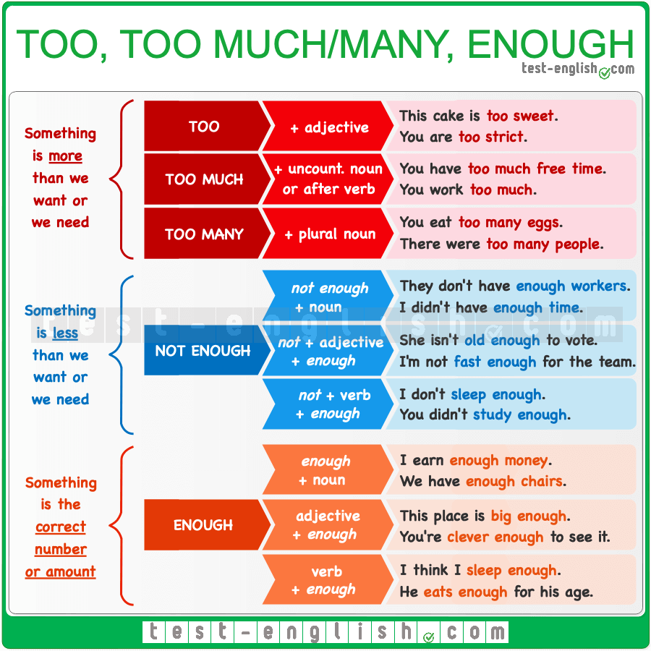

## ****Too****

#### Before an adjective/adverb

We use **too** before an **adjective** or an **adverb** to mean ‘more than we need’ or ‘more than is necessary’.

* You are **too young** to enter this club.
* We arrived **too late**.

## ****Too much****

#### Before an uncountable noun

We can use **too much** before **uncountable nouns** to mean ‘more than we need’ or ‘more than is necessary’.

* The doctor said that I drink **too much coffee**.
* I hate this city. There’s **too much traffic**.

#### After a verb

We can also use **too much**after a **verb**.

* You can’t take the car. You’**ve drunk too much**.
* He **talks too much**.

## ****Too many****

#### Before a plural noun

We use **too many** before **plural nouns** to mean ‘more than we need’ or ‘more than is necessary’.

* I didn’t enjoy the concert. There were **too many people**.
* They lost because they made **too many mistakes**.

## ****Enough****

#### Before a noun

We can use **enough** + **noun** to say that something is the correct number or amount.

* I have saved **enough money** to go to Rome on holiday.
* Do you have **enough butter** to cook?

In negative sentences, we use **(not) enough** + **noun** to say that something is less than we want or need.

* We **don’t** have **enough money** to travel.
* I **don’t** have **enough time** to finish my homework before Monday.

#### After an adjective/adverb

We can use **adjective/adverb**+ **enough** to mean ‘sufficiently’.

* This bed is **big enough** for the four of us.
* I think she spoke **clearly enough**. Everybody understood what she meant.

In negative sentences, we can use **(not) adjective/adverb + enough** to mean ‘less than we want’ or ‘less than necessary’.

* You **aren’t** **old enough** to enter this club.
* You **aren’t** going **fast enough**. We are going to be late.

#### After a verb

We can also use **verb** + **enough**.

* I **didn’t study enough**, and I failed the exam.
* I think you **don’t sleep enough**. You should sleep seven or eight hours a day.

## ****Too, too much, too many, enough**** + ****to**** + infinitive

In English, we often use a **to**-infinitive with the expressions **too, too much, too many, enough**.

* I was **too tired to go** clubbing.
* She makes **enough money to sustain** her family.

## Be careful with these common mistakes!

Don’t use an adjective after **too much**

* I’m **too much tired** to study now. 
* I’m **too tired** to study now. 

Don’t confuse the word **too** (=more than enough) with the word **very**.

* I think she is **too** beautiful. 
* I think she is **very** beautiful. 

## ****Most, most of, the most**** : Grammar chart

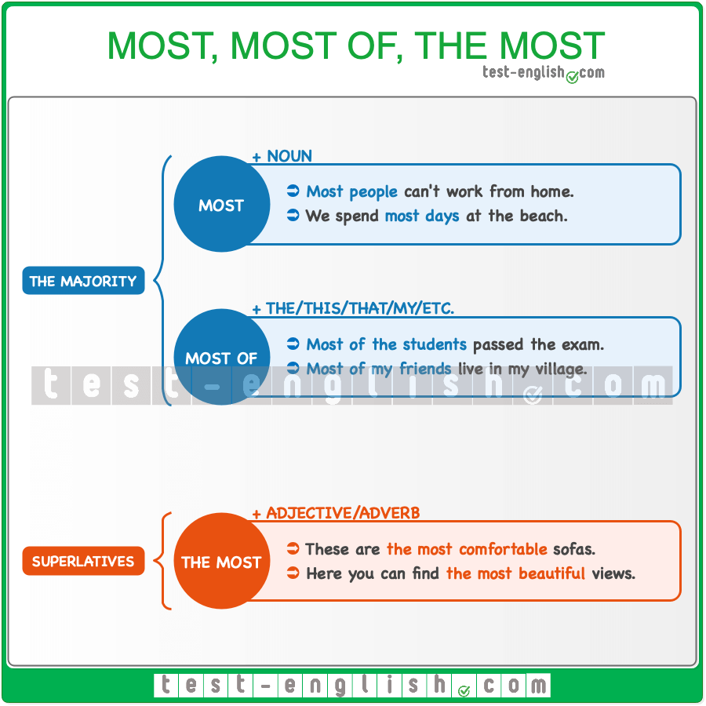

### ****Most****

We use **most** (without **the/this/that/my/etc.**) with nouns to mean ‘the majority of’ something.

* **Most of people** can’t work from home. 
* **Most people** can’t work from home. 
* I have some bad days, but **most days** are good.

We can use **most** + noun to talk about the majority of people or things in general

* **Most students** like online learning.

### ****Most of****

We use **most of** before **the/this/that/my/etc.**

* **Most of students** in my class practice sports. 
* **Most of the students** in my class practice sports. 
* **Most of this information** is not true.

We can also use **most of** + object pronoun.

* **Most of us** come from poor families.
* They arrested **most of them**.

#### Be careful with this common mistake!

We say **most** or **most of** (NOT **the most**) to talk about the majority of something.

* **The most students** like online learning. 
* **Most students** like online learning. 
* **The most of us** come from poor families. 
* **Most of us** come from poor families. 

### ****The most****

We say the most before adjectives or adverbs to make the superlative form.

* These are **the most comfortable** sofas you can buy.
* Here, you can find **the most beautiful** views in the region.

## Personal pronouns and possessive adjectives: Grammar chart

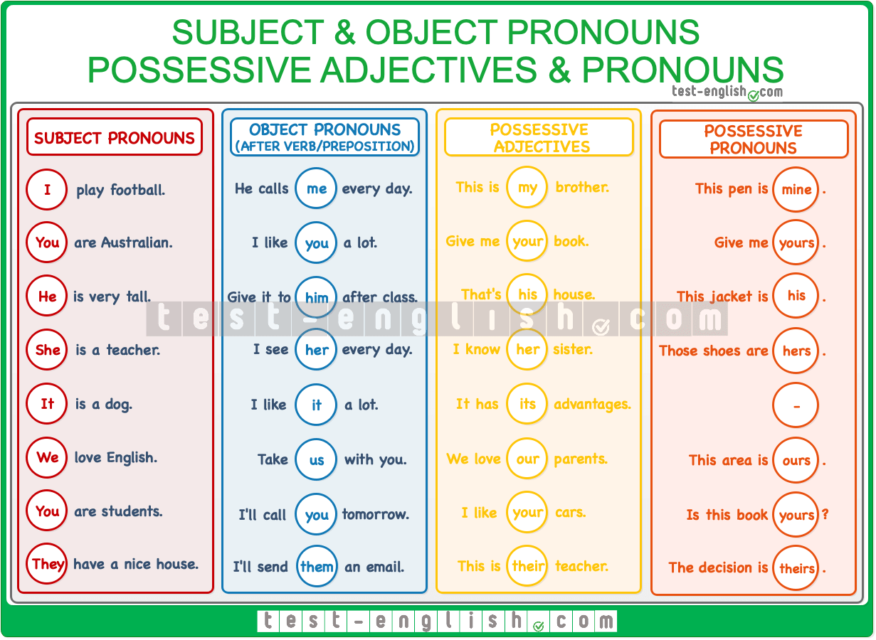

## Subject pronouns

#### Before the verb

We use **subject pronouns**as the subject of the verb (before the verb).

* I like your dress.
* You are late.
* He is my friend.
* It is raining.
* She is on holiday.
* We live in England.
* They come from London.

## Object pronouns

#### After the verb

We use **object pronouns**as the object of the verb (after the verb).

* Can you help me, please?
* I can see you.
* She doesn’t like him.
* I saw her in town today.
* We saw them in town yesterday, but they didn’t see us.

#### After a preposition

We use **object pronouns**after prepositions.

* She is waiting for me.
* I’ll get it for you.
* Give it to him.
* Why are you looking at her?
* Don’t take it from us.
* I’ll speak to them.

## Possessive adjectives

#### Before a noun

We use **possessive adjectives** before a noun because they modify a noun.

* My dog is big.
* Her cat is brown.
* Their sister works downtown.

## Possessive pronouns

#### Without a noun

A **possessive pronoun**is NOT followed by a noun.

* The dog is mine.
* The brown cat is hers.
* The car is ours.

#### ****Whose****

We use **whose**to ask about possession.

* Whose car is that?
* Whose is that car?

### Relative clauses, relative pronouns and adverbs

## Defining relative clauses

We use defining relative clauses to specify which person, thing or place we are talking about.  
  
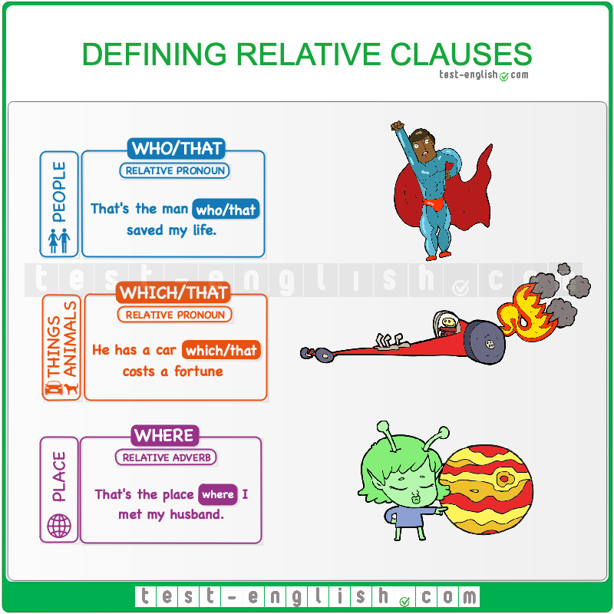

#### Who, which, where

We use **who** for people.

* He met the police officer **who** saved his life.

We use **which** for things and animals.

* He put on the suit **which** he wore for special occasions.

We use **where** for places.

* This is the hotel **where** we spent our honeymoon.

#### That

We can use **that** instead of **who** or **which**. But we often use **who** for people and **which**/**that** for things.

* He’s the neighbour **who/that** helped us to move out.
* Change the cable **which/that** connects the computer to the printer.

#### Be careful with these common mistakes!

We cannot use **what** or an expression like **that he/she/etc**. instead of **that,** **who, etc.**.

* That’s the student **what** I told you about. 
* That’s the student **that/who** I told you about. 
* That’s the man **he** tried to steal my wallet. 
* That’s the man **that/who** tried to steal my wallet. 

### Auxiliary verbs

## So and neither: So am I, neither do I, etc.

### ****So-too, neither-either**** – Grammar charts

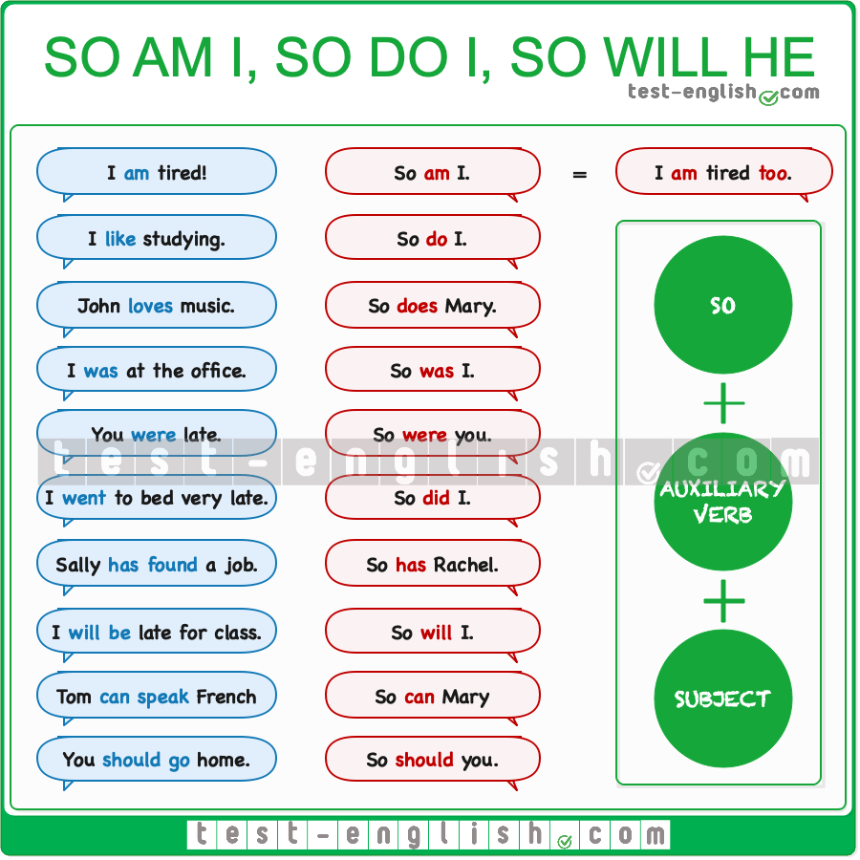

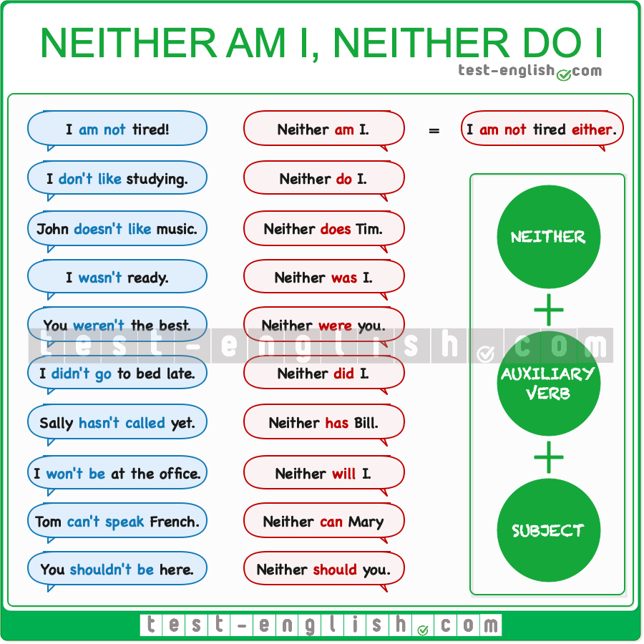

#### A is or does the same as B

To say that A is or does the same as B, we can use **so + auxiliary verb + subject** in affirmative sentences and **neither + auxiliary verb + subject** in negative sentences.

* A: “I am from London.”  B: “**So** am I.” (=I am from London too.)
* A: “I’m not tired.”  B: “**Neither** am I.” (=I am not tired either.)

#### What auxiliary verb do we need?

After **so**/**neither**, we use the same auxiliary or modal verb as in the first sentence: **be, do, have, can, will, must, etc.**

* A: “Tomas **is** not going to the party.”  B: “Neither **is** Sally.”
* A: “I’**ll** be here at 7.”  B: “So **will** I.”
* A: “Lisa **can** play the guitar.”  B: “So **can** Tim.”

When there isn’t an auxiliary or modal verb in the first sentence, we use **do/does** in the present and **did** in the past.

* A: “I want to leave.”  B: “So **do** I.”
* A: “George loves chocolate.”  B: “So **does** Bruno.”
* A: “I went to bed very late.”  B: “So **did** I.”

#### Nor = neither

We can use **nor** instead of **neither**.

* A: “I wasn’t ready.”  B: “**Nor/Neither** was I.”

#### ****Neither**** is negative

**Neither/nor** is a negative word, like **not**. For this reason, the auxiliary verb after **neither**should be affirmative.

* A: “I didn’t see the film yesterday.”  B: “Neither **didn’t** I.” 
* A: “I didn’t see the film yesterday.”  B: “Neither **did** I.” 
* A: “Ray couldn’t answer the question.”  B: “Neither **couldn’t** Jimmy.” 
* A: “Ray couldn’t answer the question.”  B: “Neither **could** Jimmy.” 

## Too, either

Another way of saying that A is or does the same as B, is the use of **too** or **either** at the end of the sentence. We use **too** for affirmative sentences and **either** for negative sentences.

* A: “I want to leave.”  B: “I want to leave **too**.”
* A: “I didn’t go.”  B: “I didn’t go **either**.”

### Adjectives and adverbs

## Comparative and superlative adjectives: Grammar chart

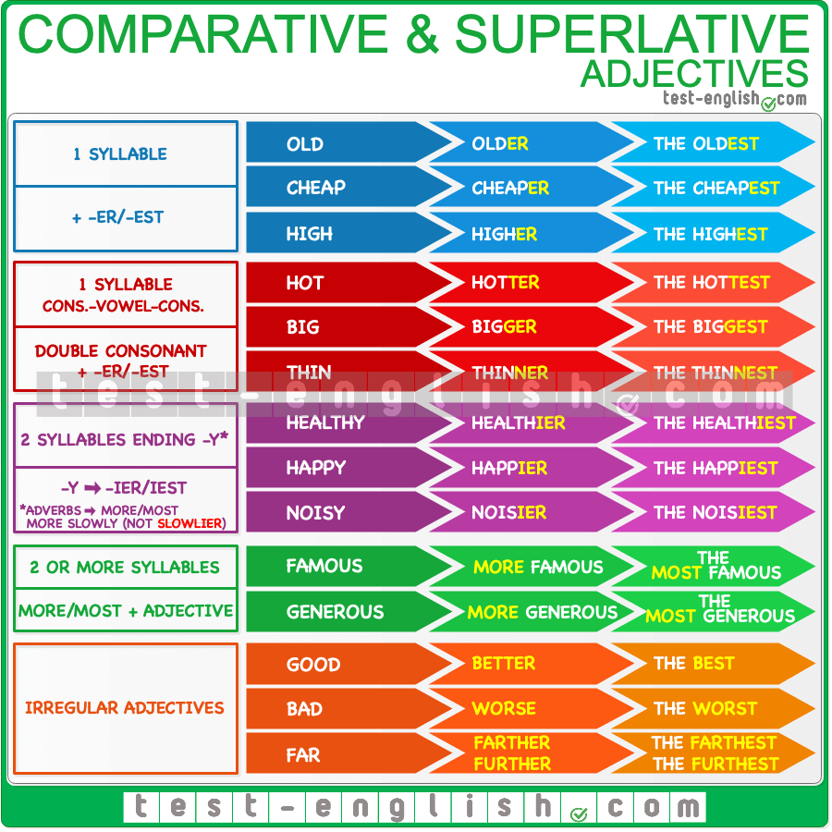

## Comparative adjectives

#### Two things

We use the comparative form of an adjective to compare two things. When we compare three or more things, we use the superlative form of the adjectives.

* White meat is **healthier than** red meat.
* Travelling by bus is **more comfortable than** travelling by train.

#### ****Less … than****

When comparing two things, we can also use the form **less** + adjective + **than** (less ≠ more).

* Peter is **less considerate than** Marta. (= Marta is more considerate)

#### ****Not as … as****

We can also use the form (**not**) **as** + adjective + **as**.

* Peter isn’t **as considerate as** Marta. (= Marta is more considerate)

#### ****Than me / than I am****

After **than** or **as … as** we can use an object pronoun (**me, you, him, etc**.), or we can also use a subject pronoun (**I, you, he, etc**.) + verb.

* My sister is taller than **me**. / My sister is taller than **I am**.
* His sister is more intelligent **than him**. / His sister is more intelligent **than he is**.

#### ****Much/a lot/a bit more****

Before the comparative (**more** or **–er**), we can use **much**, **a lot** or **a bit**.

* He’s **a bit taller** than me.
* Florence is **much more interesting** than Pisa.
* My car is **a lot more expensive** than yours.

## Superlative adjectives

#### Three or more things

We use the superlative form of an adjective or adverb to compare three or more things.

* Both John and his brother play football, but John is **better**.
* John and his two brothers all play football, but John is **the best**.

#### ****The best in****

After the superlative, we use **in** before names of places or before singular words referring to groups of people (**class, school, team, family, etc**.)

* The Everest is the highest mountain **of the world**. 
* The Everest is the highest mountain **in the world**. 
* She is the best student **in the class**.
* He’s the tallest **in the family**.

#### ****The best I’ve ever…****

We often use a superlative adjective with the present perfect tense of a verb and the word **ever**.

* This is **the best movie I’ve ever watched**.
* She is **the most beautiful woman I have ever seen**.

#### ****The / my / John’s****

Before the superlative, we always use **the** or a possessive adjective (**my, your, his, etc**.) or noun (**Paul’s, Elisabeth’s, etc**.)

* He is **the** best.
* This is **my** most expensive jacket.
* This is **Paul’s** best friend.

## Comparative and superlative adverbs

#### Compare actions

We can use the comparative or superlative form of adverbs to compare actions

* She drives fast, but I drive **faster**.
* He plays well, but I play **better** than him.

#### ****More slowly****

The adverbs that are formed by adding **-ly** to the adjective (adverbs of manner) take **more** to form the comparative and **the most**to form the superlative.

* She speaks**quietlier** than her boss. 
* She speaks **more quietly** than her boss. 
* He cooks well but **slowlier** than his workmates. 
* He cooks well but **more slowly** than his workmates. 

Adverbs of one or two syllables are like adjectives; they take **-er** in the comparative and **-est** in the superlative (**early-earlier, late-later, fast-faster, hard-harder, etc.**)

* He works **harder** than me.
* She always arrives **later** than her boss.

## No longer, any longer, anymore

We use the phrases **no longer**, **any longer**, and **anymore** to talk about something that happened or was true in the past but doesn’t happen or isn’t true now. Although their meanings are the same, the way we use them is not. **No longer** is also slightly more formal than **any longer** and **anymore**.  
  
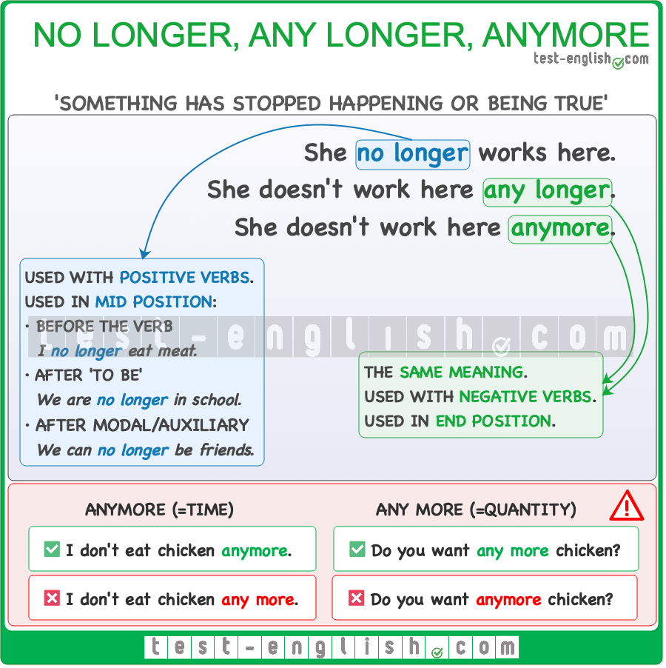

### No longer

Unlike **any longer** and **anymore**, **no longer** is only used in positive sentences as it makes a sentence negative. Its position is different, too, as it is typically used in the **mid position**. The mid position is between the subject and the verb.

* I **no longer** eat meat.
* He **no longer** plays football.

With the verb **to be**, however, the mid position is **after the verb**.

* We are **no longer** friends.
* He is **no longer** a footballer.

With modal or auxiliary verbs, the mid position is **after the modal verb**.

* Jim will **no longer** attend his lessons.
* We can **no longer** bring phones to school.

In questions, the mid position is **after the subject**.

* Do you **no longer** want to play?
* Is he **no longer** happy?

### Any longer, anymore

**Any longer** and **anymore** are only used in **negative statements or questions**. Both expressions are synonyms and can be used interchangeably. They are always placed **at the end** of a statement or question.  
  
**Any longer** is slightly more formal than **anymore**.

* We don’t live there **any longer/anymore**.
* We aren’t friends **any longer/anymore**.
* Why don’t you visit us **any longer/anymore**?

### Anymore vs any more

**Anymore** (one word) is often confused with **any more** (two words), and though the two may look similar, their meanings are completely different.  
  
**Anymore** is an adverb referring to time; it means ‘not now like before’. For example, “I don’t eat pizza anymore” means ‘I used to eat pizza in the past, but I don’t eat pizza now’.  
  
On the other hand, **any more** is a determiner used to describe quantity; it means ‘additional’ or ‘more than what we have now’. For example, “Do you have any more candy?” means ‘Do you have additional candy (or more candy than what you gave me)?’

* I don’t eat chicken **anymore**. 
* I don’t eat chicken **any more**. 
* Do you want **any more** chicken? 
* Do you want **anymore** chicken? 

### Conjunctions and clauses

## However, although, because, so

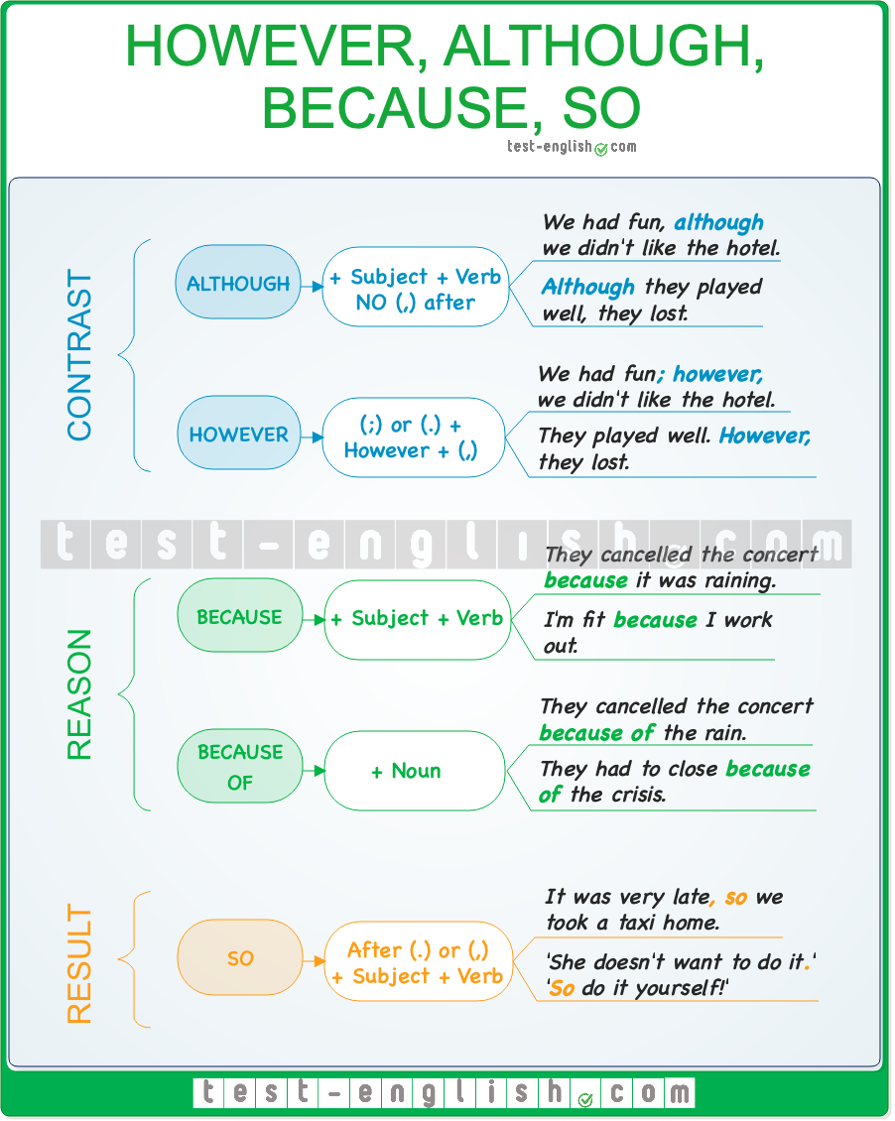

## Clauses of contrast

#### However

**However** means ‘but’.

**However** is normally used at the **beginning of a sentence**, **before** a comma **(,)** and **after** a full stop **(.)** or a semicolon **(;)**.

* We didn’t like the hotel**.** **However,** we had a good time.
* I would like to have a dog**; however,** my husband is allergic to dogs.

#### Although

**Although** means ‘despite the fact that’ or ‘but’.

**Although**can be used at the **beginning** or in the **middle** of a sentence. We do **NOT** use a **comma** after although; we use **although + subject + verb**.

* **Although** he had a bad leg, he still won the game.
* I passed the exam, **although** I hadn’t studied.

## Clauses of reason

#### Because

We use **because + subject + verb**.

* We had to cancel the concert **because** it was raining.
* I didn’t call you **because** I didn’t want to worry you.

#### Because of

We use **because of + noun**.

* We had to cancel the concert **because of** the rain.
* Many shops had to close **because of** the economic situation.

## Clauses of result

#### So

**So** is the most common connector to express **result**. It is normally used in the **middle** of a sentence after **(,)**.

* We worked hard all morning, **so** I am very tired now.
* The TV is very expensive, **so** I don’t think I’ll buy it.

## Time connectors

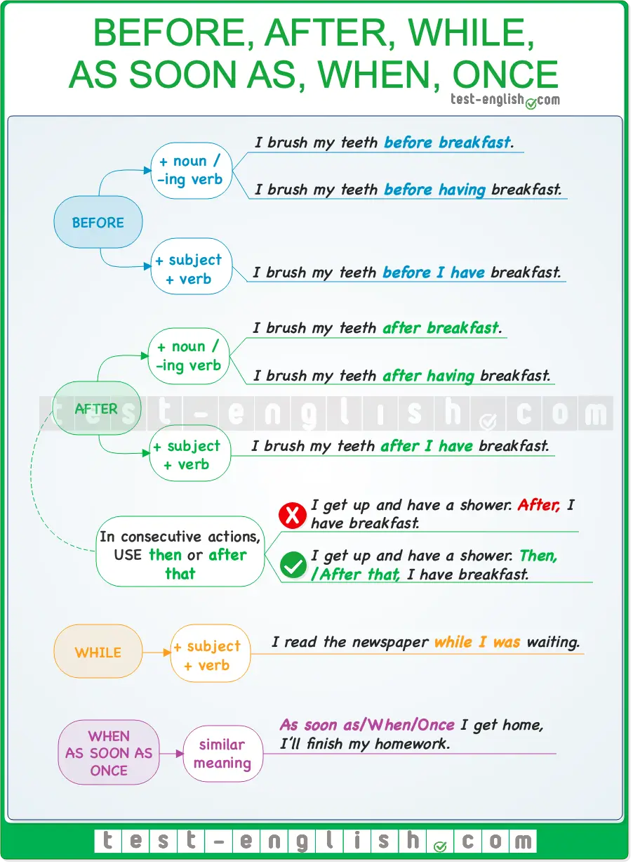

#### Before

We can use **before + noun** / **-ing verb**, or we can use **before + subject + verb**.

* **Before** I have breakfast, I read a few pages.
* **Before** having breakfast, I read a few pages.
* **Before** breakfast, I read a few pages.

#### After

We can use**after + noun** / **-ing verb**, or we can use **after + subject + verb**.

* I smoke a cigarette **after** dinner/ having dinner/ I have dinner.

When we are talking about **consecutive actions**, we use **then** of **after that**, but NOT **after**.

* I got up and had a shower. **After**, I made breakfast. 
* I got up and had a shower. **Then/After that**, I made breakfast. 

#### While

We use **while** **+ subject + verb** to talk about actions happening at the same time, simultaneously.

* I read the newspaper **while** I was waiting.

#### As soon as, when, once

**As soon as**, **when**, and **once** have a similar meaning. As soon as means ‘immediately when’.

* **As soon as/when/once** I get home, I’ll finish my homework.

## Common mistakes

We use the present simple and NOT **will** to express future after **before, after, as soon as, when,** and **once**.

* **When** I **will get** home, I’ll call you. 
* **When** I **get** home, I’ll call you. 

We use a **comma** after the **first part of the sentence** when we start with **before, after, while, as soon as, etc**. But we do **not** use a **comma** if we use **before, after, while, as soon as, etc**in the **second part of the sentence**.

* **Before** I go to bed**,** I brush my teeth.
* I brush my teeth **before** I go to bed.

### Prepositions

## Prepositions of movement

We use prepositions after verbs to describe the direction of **movement**. It’s common to use these prepositions after verbs that describe movement (**walk, run, come, go, drive, cycle, fly,** etc.), although it is also possible to use them after other types of verbs (We talked over the fence, I looked into the room, etc.) or after nouns (the path to the beach, the road from Leeds, the way up the hill, etc.)  
  
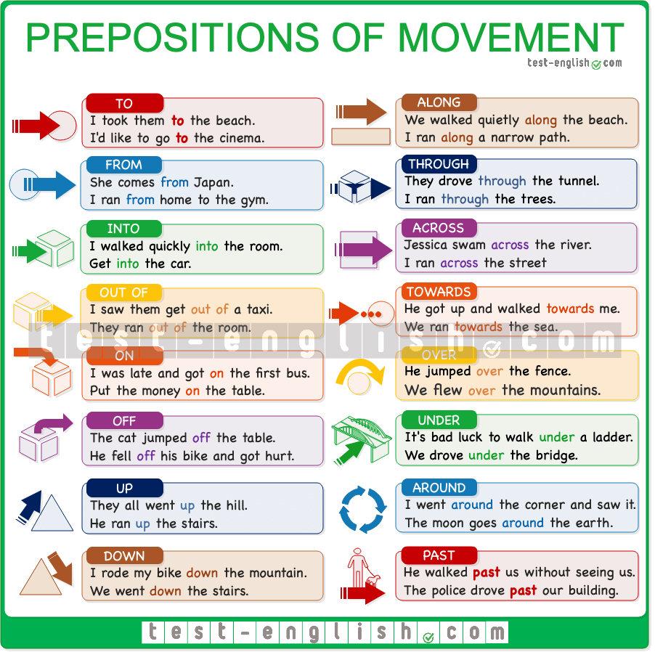

## Get on/off the bus or train, get into/out of the car

We say **get in** and **get out of** for a car, taxi, or van, but we say **get on** or **get off** for motorbikes and bicycles and for public means of transport, such as a bus, a train or a plane.

* I have to **get off the bus** at the next stop.
* He stopped and **got out of** the car.

## Go to work by car= drive to work

When we want to talk about how we go from place A to place B, we can do it in two different ways:

➟ Using **by**+ **means of transport** (car, taxi, plane, bike, etc.) or using **on**+ **foot**.

* I go to school **on foot**.
* I go to work **by car**.
* I went to Zurich **by plane**.
* I went to the airport **by taxi**.

➟ Using a verb of movement (**walk, drive, fly, cycle, etc**.) or for public transport, using **take** + **means of transport**.

* I **walk** to school
* I **drive** to work.
* I **flew** to Zurich.
* I **took a taxi/a bus/a train/etc.** to the airport.

## On time vs In time, At the end vs In the end

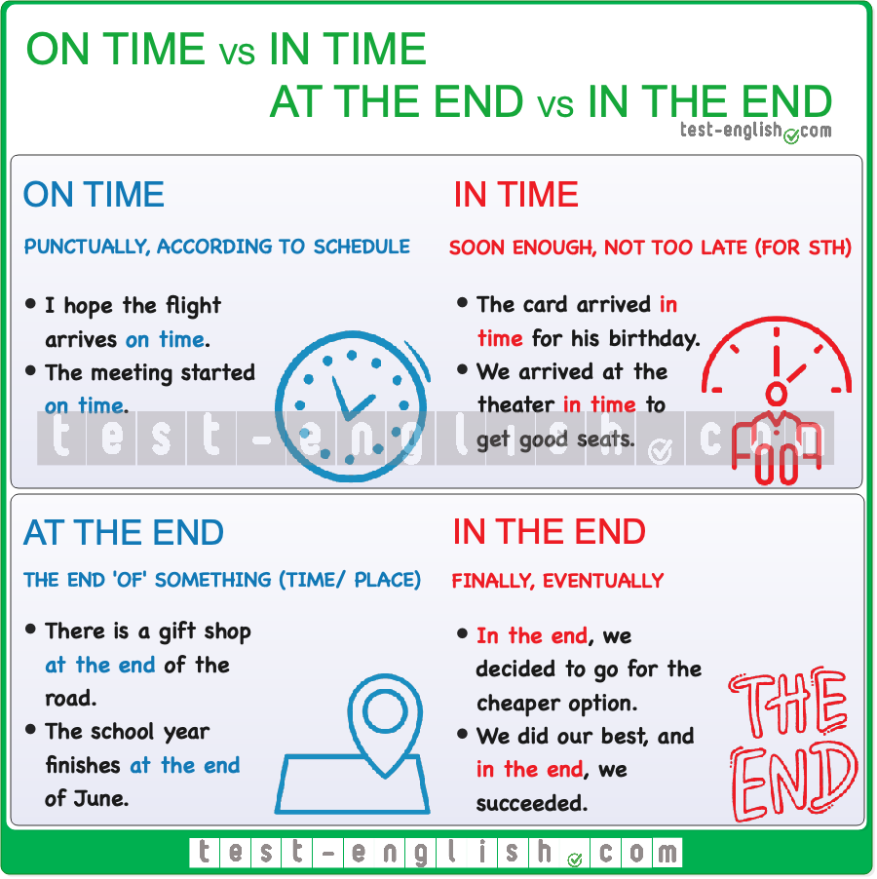

### On time vs In time

**On time** means ‘punctually’ or ‘according to schedule’. When something happens **on time**, it means that it happens at the time that is expected. For example, if a train, a bus, or a person is expected to arrive at 8 am and they arrive **on time**, it means that they arrive at 8 am. **On time** often refers to a scheduled event, such as the arrival of a flight, the start of a film, or the punctual arrival of a person.

* I hope the flight arrives **on time**.
* The meeting started **on time**.

**In time** does not refer to punctuality. It means ‘soon enough’, or ‘not too late’. When you are **in time**, it means you are not too late, and it often means that you are early enough to spare time and do something else. It’s common to use **in time** with **for**+ noun or **to +** infinitive

* I hope the card arrives **in time for** his birthday.
* We arrived at the theatre **in time to** get good seats.

We often say **just in time** to talk about something that happens at the last moment, just before it’s too late.

* The pizza arrived **just in time** for our movie night.
* She arrived at the airport **just in time** to catch her flight.

### At the end vs In the end

**At the end** is used to refer to the end, or final part, of something physical or of a time. We normally say **at the end of** + noun: the day, the street, the year, the book, etc.

* **At the end of** the play, the crowd applauded.
* There is a gift shop **at the end of** the road.
* The term finishes **at the end of** May.

**In the end** means ‘finally’ or ‘eventually’. It indicates how a situation ended or was resolved, and it is the opposite of **at first**. When **in the end** is used at the beginning or in the middle of a sentence, it is followed by a comma.

* **In the end,** we decided to go for the cheaper option.
* We did our best, and **in the end**, we succeeded.
* **In the end**, the results were disappointing.

### Questions

## Word order in questions: Grammar chart

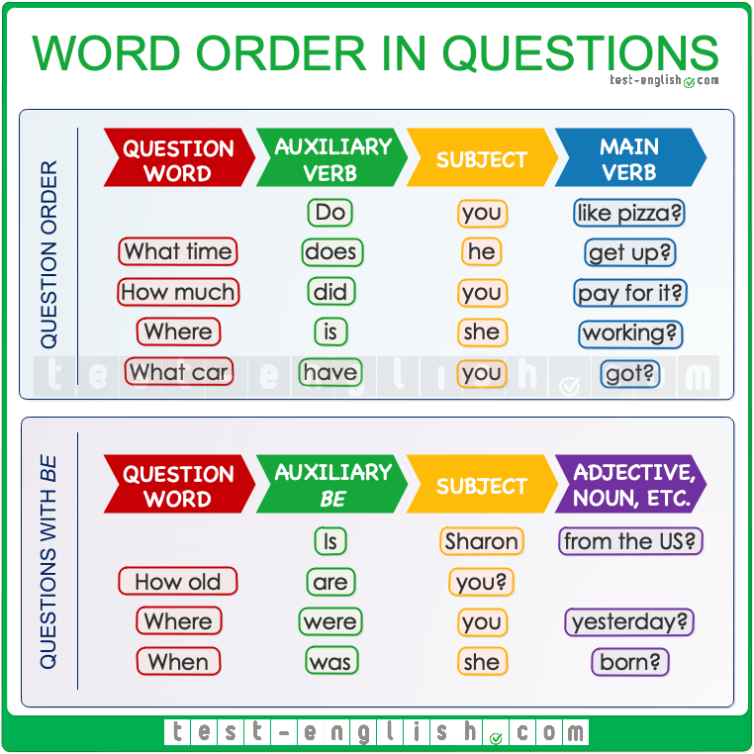

#### Questions in general

If we want to ask a question in English, the order is **QWASM**: **Question word, Auxiliary verb, Subject, Main verb**. In **Yes-No questions** (questions where the answer is **yes** or **no**), there is no Question Word.

#### Questions with ****be**** as the main verb

When **be** is the main verb, it is used as the **Auxiliary** in the question, and then we don’t have a **Main verb** after the Subject.

#### Auxiliary verbs

In the position of **Auxiliary**, we can use **be**, **do**, **have** or any modal verb: **can, could, will, would, should**, etc.

**Have** is only an auxiliary verb in the form **have got** and in the **present perfect**.

* **Have** you **got** any brothers or sisters?
* What **have** you **cooked** for lunch?

For other uses of **have**, we need an auxiliary verb (**do**, **did**) for questions.

* What time **had you** dinner yesterday? 
* What time **did you have** dinner yesterday? 
* **Have you** to do it now? 
* **Do you** **have** to do it now? 

**Have got** only has a present form. It does not have a past form.

* **Had you got** many toys when you were a child? 
* **Did you** **have** many toys when you were a child? 

## Question words

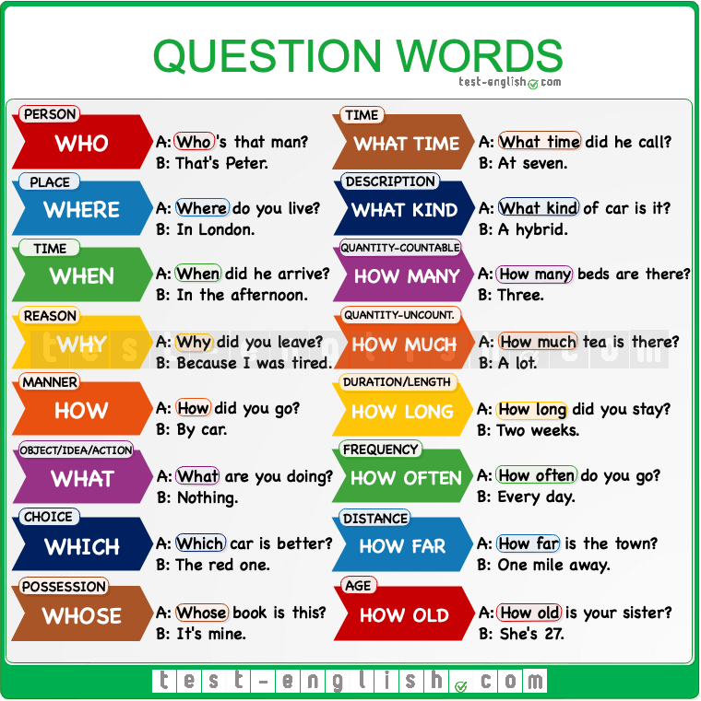

#### ****How much****

We can use **how much** to ask about the price of something.

* **How much** is the jacket?

#### ****How**** + adjective

We can use **how + adjective** (any adjective) as a question word.

* **How tall** are you?
* **How fast** is your car?

#### ****Which**** vs ****what****

We can use **which + noun**, and we can also use **what + noun**. We use **which** when there are a small number of possible answers. Look at the difference:

* **Which** car do you like, the red or the blue? (there is a small number of possible answers)
* ‘**What** car have you got?’ ‘A Mercedes.’ (many possible answers)

## Subject questions and object questions

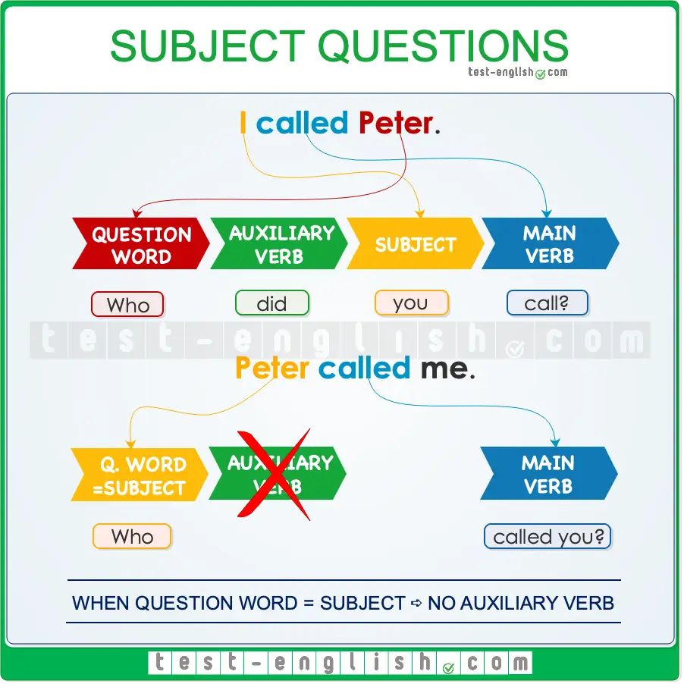

In the **present and past simple** tenses, we do not use an auxiliary verb (**do/does** or **did**) after the question word if the question word (**who, what, etc.**) is the subject of the sentence.

* **Who did win** the match? 
* **Who won** the match? 
* **What did happen** last night? 
* **What happened** last night? 
* **How many people did go** to the party? 
* **How many people went** to the party? 

This rule applies specifically to the **present and past simple** tenses. For other tenses (present continuous, present perfect, etc), where the auxiliary verb is part of the verb form, we include the auxiliary verbs in subject questions.

* Who **is** cooking dinner tonight?
* Who **has** eaten all the cookies?

When we are asking about the object (after the verb), we use the normal order of the English question: **auxiliary verb + subject**. These types of questions are called object questions.

#### Object question vs subject question

|  |  |
| --- | --- |
| Jack called Teresa. (Teresa = object) | Jack called Teresa. (Jack = subject) |
| Who did Jack call? (Who = object) | Who called Teresa? (Who = subject) |

## Questions with preposition

In informal or spoken English, when a question word needs a preposition, the preposition goes at the end of the question (after the verb or after verb + object if there is an object). We don’t use the preposition at the beginning.

* I played tennis **with John**. ⇒ **Who** did you play tennis **with**?
* I work **for a multinational company** ⇒  **What** company do you work **for**?
* We usually talk **about sports**. ⇒ **What** do you usually talk **about**?